Instructions……………………………………………………………………………………………………………………………….............2

DocuSign PowerForm Instructions - Employee/Staff Aug/GEC Version A…………………………………….........3

DocuSign PowerForm Instructions – Consultant/Contractor/Outside Agency Version B.......................6

Instructions

Policies and Procedures:
- Read the policies and procedures to ensure that you are familiar with the Department’s policies. This step is important because completion of the FDOT Transportation Technology Acceptable Use Agreement (AUA) form requires that you abide by these policies.

Complete the FDOT Transportation Technology Acceptable Use Agreement (AUA) form:
A separate Acceptable Use Agreement (AUA) form must be completed for each user ID being requested. The user must read the policies and procedures and take the Computer Security CBT. This CBT is available on the FDOT.gov cybersecurity website. https://www.fdot.gov/cybersecurity/it-resources/computer-security-cbt

- Open the appropriate FDOT Acceptable Use Agreement form, #325-060-08.
  - There are two versions of the form.
    - Employee/Staff Aug/GEC (a)
    - Consultant/Outside Agency (b)
  - The two versions of the form can be found as a DocuSign PowerForm on the Forms website, the AARF Help Page and the https://www.fdot.gov/cybersecurity website.

Read the information and requirements on the first 3 pages:

- Your Responsibilities
- What You CAN Do
- What You CANNOT Do
- What Can I Connect To?
- Resources

DocuSign PowerForm:
The Acceptable Use Agreement (AUA) form is available to complete as a DocuSign PowerForm.
- Click on the appropriate FDOT Acceptable Use Agreement (AUA) form link.
  - There are two versions of the form.
    - Employee/Staff Aug
    - Consultant/Outside Agency

Complete the Initiator and User Information – Employee/Staff Aug:

From the PowerForm page for Employee/Staff Aug, the Initiator will enter their Full Name and their email address. Next, enter the Full Name of the Employee or Staff Augmentation/GEC user that needs to sign the AUA and their email address. The form can be viewed via desktop, phone, or tablet. Once the fields are filled out, click Begin filling out form.
There is an optional field where you may add anyone else that may need to receive a copy of the completed document. For example, the user’s Supervisor. They are not included in the signing process.
Note: The Initiator and the person needing to sign may be the same person. If the Initiator and the Employee/Staff Aug are the same person, you will first view the AUA. Then you will receive an email from DocuSign to sign the document.
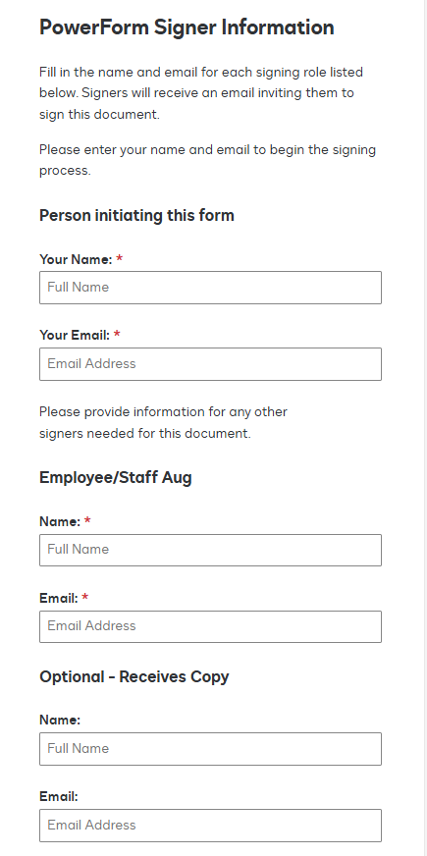
If the Initiator is not the user that must sign the form, the Initiator will be able to read the AUA form, but no action is needed other than to Close the PowerForm.
Once the form is closed an email will be sent to the Employee or Staff Aug/GEC that needs to review and sign.
The email comes from Heather McClellan via DocuSign as she is the owner of the DocuSign PowerForm.
Example
From inside the email, the Employee or Staff Aug/GEC who needs to sign will click on Review Document to access and sign the form.
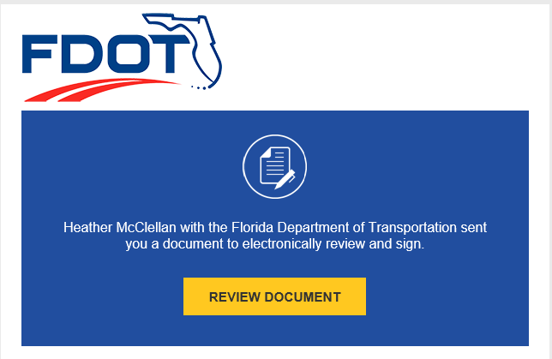
Once inside the DocuSign page, the Employee or Staff Aug/GEC will click Continue.
Now the Employee or Staff Aug/GEC will be able to digitally sign the form. They must select Yes or No for the question if they have ever previously worked for or with FDOT.
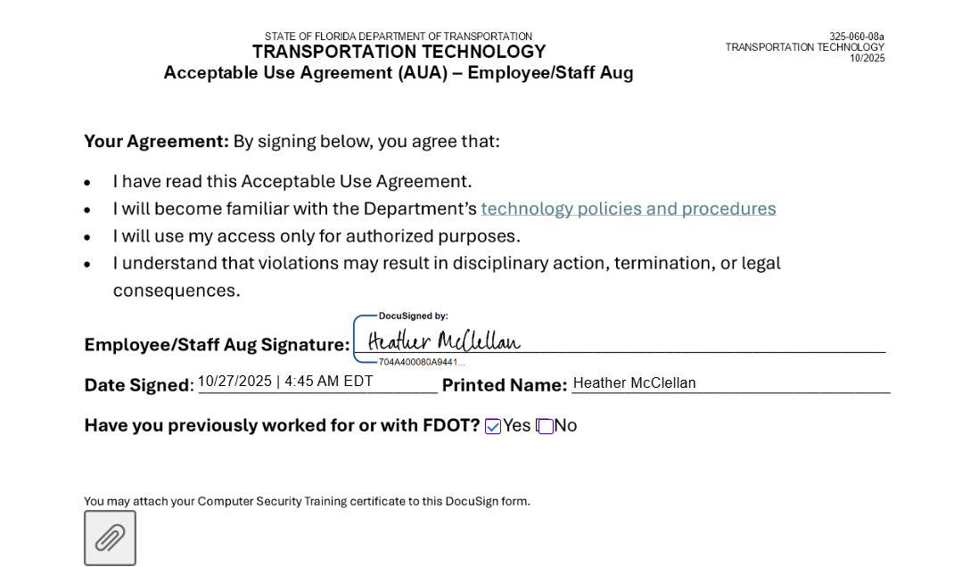
The user also has the option to attach their completed Computer Security CBT directly inside the AUA DocuSign form.
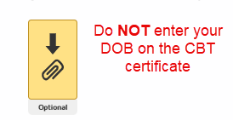
Once the Employee or Staff Aug/GEC has signed and marked the correct checkbox, click on Finish.

Now that the document has been completed, the Initiator and the Employee or Staff Aug/GEC that signed the form will receive an email with the completed document. If there was a name & email entered for the Optional – Receives Copy – it will be sent to that user as well.
It will contain the document as a pdf and a link to view the completed document online.
Submit your completed forms to your future Supervisor/FDOT Project Manager.

Complete the Initiator, User and Contact Information – Consultant/Contractor or Outside Agency:

From the PowerForm page for Consultant/Outside Agency users, the Initiator will enter their Full Name and their email address. Next, enter the Full Name of the Consultant/Contractor or Outside Agency User that needs to sign the AUA and their email address. Lastly, enter the Full Name of the Company Manager or the Outside Agency Contact that will be signing the AUA. The form can be viewed via desktop, phone, or tablet. Once the fields are filled out, click Begin filling out form.
There is an optional field where you may add anyone else that may need to receive a copy of the completed document. For example, the user’s Supervisor. They are not included in the signing process.
Note: The Initiator and person who needs to sign may be the same person. If the Initiator and the Consultant/Contractor or Outside Agency User are the same person, you will first view the AUA. Then you will receive an email from DocuSign to sign the document.
Since the Initiator may not be the user that must sign the form, the Initiator will be able to read the AUA form, but no action is needed other than to Close the PowerForm.
Once the form is closed the email will be sent to the Consultant/Contractor or Outside Agency User that needs to review and sign.
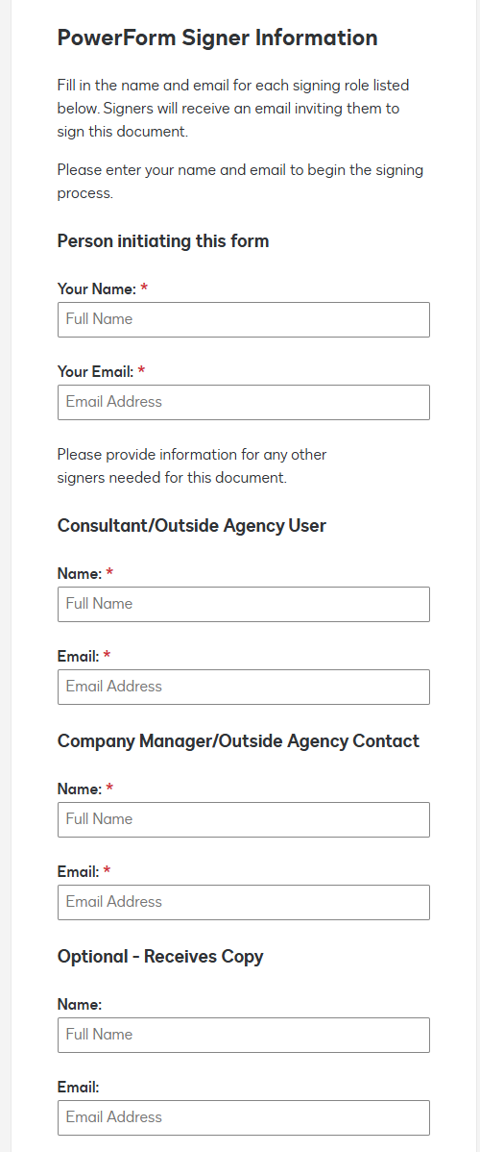

After the Consultant/Contractor or Outside Agency User has reviewed the document, they will fill in their Company Name or Agency Name, phone number and answer the question inquiring if they have previously worked for or with FDOT. The user will enter their company’s FEIN/Tax ID # if known. The user’s name will be displayed as it was entered on the initial PowerForm page.
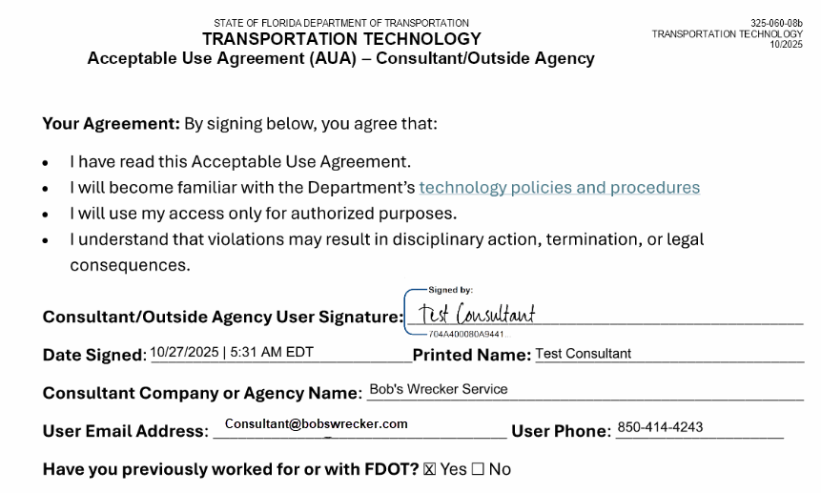
The user also has the option to attach their completed Computer Security CBT directly inside the AUA DocuSign form.
Once the Consultant/Contractor or Outside Agency User has signed and marked the correct checkbox, click on Finish.
DocuSign will return you to a DocuSign for FDOT web page.
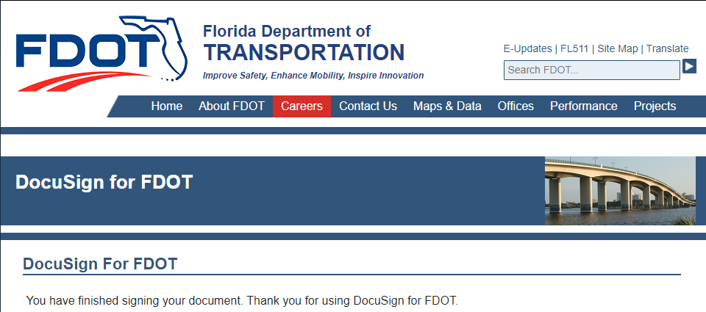
Next, the Company Manager or Outside Agency Contact will receive an email from DocuSign.
From inside the email, they will click on Review Document to complete and sign the form.
From the DocuSign page you will click Continue.
NOTE: If the company’s FEIN/Tax ID # was not previously entered, it will be a required field. The Company Manager or Outside Agency Contact will fill in their phone number, their title and then sign the document.
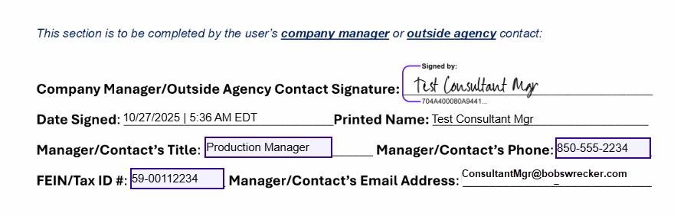

Once the Company Manager or Outside Agency Contact has signed it, they will click on Finish.
DocuSign will return them to a DocuSign for FDOT web page.
Now that the document has been completed, the Initiator, the Consultant/Contractor or Outside Agency User and the Company Manager or Outside Agency Contact will each receive an email with the completed document. If there was a name & email entered for the Optional – Receives Copy – it will be sent to that user as well.

It will contain the document as a pdf and a link to view the completed document online.
Submit your completed forms to your future FDOT Project Manager.

