MPOAC Noteworthy Practices Working Group

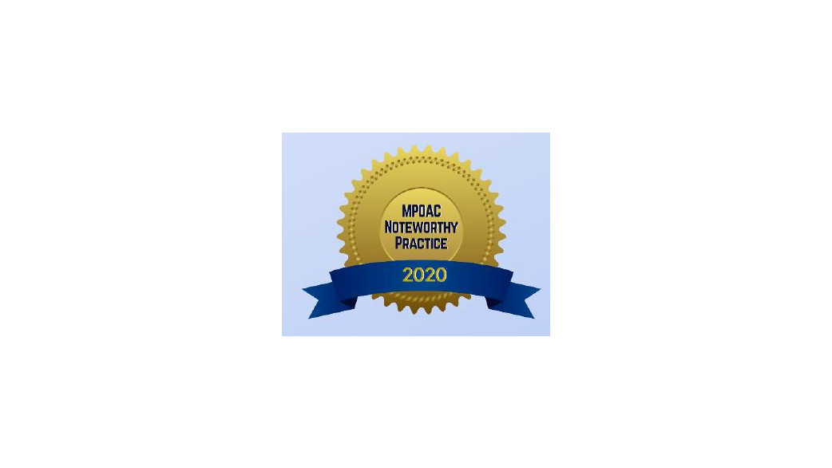
Date: Thursday, April 27, 2023

Time: 10:30 a.m. – 11:30 a.m.

Location: The Florida Hotel
1500 Sand Lake Road
Salon 2 Meeting Room
Orlando, FL 32809

Please join my meeting from your computer, tablet or smartphone.
https://meet.goto.com/MPOAC-Lisa/mpoac_meetings-april272023
You can also dial in using your phone.
Access Code: 269-060-669
United States: +1 (224) 501-3412
Chair Beth Alden
Vice-Chair Peter Buchwald, Presiding

- Call to Order & Introductions

- Approval of Minutes: October 27, 2022

- Public Comments (non-agenda items)
- Brief Updates
  - NCHRP implementation grant application – Wade Carroll

- Nominate and vote on October proposals for Noteworthy Practices Awards
  - Award in a Planning Emphasis Area
  - Award for a MPO Core Function (TIP, LRTP, UPWP, PPP, CMP, TPM, etc.)
    - Guiding Principles
      - Clarity/Effective Communication
      - Innovation
      - Results/Outcomes
      - Partnerships/Collaboration
      - Transferability

- Member Comments

- Adjournment

Any person who desires or decides to appeal any decision made by this Council with respect to any matter considered at this meeting will need a record of the proceedings. For such purposes, such person may need to ensure that a verbatim record of the proceedings is made which record includes testimony and evidence upon which appeal is to be based.

The needs of hearing or visually impaired persons shall be met by contacting the Council sponsoring such meeting at least 48 hours prior to the meeting. Please contact Lisa Stone at (850) 414-4037 or by email to lisa.stone@dot.state.fl.us.

