2022 Child Restraint Survey
Final Report
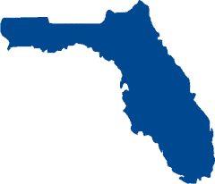

Prepared for:
Florida Department of Transportation
State Safety Office

Prepared by:
Preusser Research Group, Inc.

August 2022

Protecting Children Riding in Passenger Vehicles
fLORIDA lAW PROTECTING CHILD Passengers

Statute 316.613
Florida law requires all children from birth through age 3 be placed in a restraint device that is a separate carrier or a vehicle manufacturer’s integrated car seat.

Florida law requires all children 4 through 5 years of age to ride in a separate carrier, an integrated child seat or child booster seat, or safety belt.

The Florida Department of Transportation and the Florida Department of Highway Safety and Motor Vehicles recommends keeping children ages 12 and under in the back seat.

What is the fine for a child restraint violation? Fines start at $60.00 and 3 points, but the dollar amount can vary by local jurisdiction.
Child safety seats have been shown to reduce fatal injury by 71 percent for infants (under 1-year old) and by 54 percent for toddlers (1 through 3 years old) in passenger cars. The corresponding reductions in light trucks are 58 percent and 59 percent, respectively. Among children under 5 years old, an estimated 352 lives were saved nationwide in 2017 by restraint use (National Highway Traffic Safety Administration [NHTSA], 2019).
Data also shows that older children and adults alike are far more likely to survive a severe crash with less injury when wearing a safety belt (Centers for Disease Control [CDC], 2017).
Florida’s Child Restraint Laws
Florida law (Florida Statute 316.613) requires that children 5 years of age or younger must be properly restrained no matter where they are sitting in the vehicle. Children through age 3 must be secured in a separate carrier or a vehicle manufacturer's integrated child safety seat. For children ages 4 through 5 years, a separate carrier, an integrated child safety seat, or a safety belt may be used.
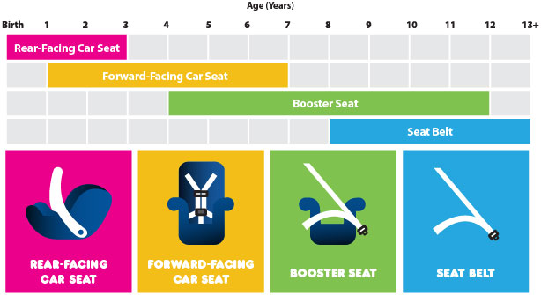
Child safety experts recommend that children aged 12 and under should ride properly buckled in the back seat. Airbags can kill young children riding in the front seat. A rear facing car seat should never be used in the front seat or in front of an airbag.
Types of Restraint
Type of restraint is determined based on age, weight, and height of the child. The device manufacturer provides directions that should be followed.
Information on types of restraint and experts who can help answer questions on proper seats and correct installation can be located at the Florida Occupant Protection Resource Center’s web portal:
https://www.floridaoprc.ce.ufl.edu/oprc

2017-2022 Child Observational Surveys
The Florida Department of Transportation (FDOT) contracting with Preusser Research Group, Inc. (PRG) developed and conducted an observational survey during the Spring of 2017 that estimated child restraint use across the state of Florida. The survey included one-hour observation periods across 200 distinct sites. These 200 sites were spread across 20 counties (10 per county). The 20 counties covered the 10 television/radio Designated Market Areas (DMA) serving the State of Florida. The two most populated counties in each DMA were selected. PRG replicated the survey in the Springs of 2018 and 2019. For 2020, due to COVID-19, the survey was conducted during the month of July. In 2021, data collection reverted back to the Spring timeframe (March/April). The 2022 data collection also took place over March and April.
Trained data collectors were positioned near daycare centers, shopping centers, recreational areas, and fast-food restaurants. These sites were selected to maximize the number of children in the vehicles observed. The data collected included: types of child restraint used in rear and front seats; estimated age of child passenger(s) (ages: 0-3; 4-5; 6-12); driver characteristics (sex, age, race); and vehicle type (car, SUV, pickup, van). A copy of the data collection form used by observers is appended to this Final Report.
2022 Survey Results
CHILD RESTRAINT USAGE
FOR YEARS 2017–2022
Observers collected usage data on 5,371 children riding in 4,739 passenger vehicles. In most cases, information was collected on 1 child per vehicle. However, observers could collect information on up to 2 children. The survey results indicated that 83 percent (+/- 1.01; 95% confidence) of children, ages 0-12, were restrained across the state of Florida. The observed rate in 2022 was slightly lower than the 2021 rate (84%) but higher than both 2020 and 2019 rates (82%). The highest rate was measured in 2017 (86%).
Usage by Age Category
Observers also estimated an age category for all 5,371 observed children. The survey results indicated that youngest children (ages 0-3; n=1,773) were restrained most often (95%). Children ages 4 to 5 (n=965) were restrained least often (75%), and older children (ages 6-12; n=2,633) were observed restrained 77 percent of the time.
2022 RESTRAINT USAGE BY AGE CATEGORY
The graphs to the right show observed use by age category comparing survey years 2017 through 2022. The percentages displayed in orange represent unrestrained children and the percentages in blue represent the proportion restrained.
RESTRAINT USE BY AGE CATEGORY
FOR YEARS 2017–2022
The top graph displays usage among child passengers ages 0-3. Children in this age group should be restrained in rear-facing carriers or forward-facing car seats depending on age, weight, and height. Survey results indicate that children observed in this age group were most often restrained with little difference in the proportion restrained year-to-year.

The middle graph displays usage among child passengers ages 4-5. Children in this age group are typically beyond the weight and height of children who should use rear facing carriers. Some are beyond forward-facing car-seats too and using a booster seat would be most appropriate. This age group is less likely restrained compared to the younger children. After reaching a high of 79 percent usage in 2021, this rate fell 4 percentage points to 75 percent in 2022.

The bottom graph shows usage among child passengers ages 6-12. The younger children in this age group are, by and large, the appropriate size for booster seats, while older children have grown to the appropriate size for safety belts. Children in this age group typically had higher usage than those ages 4-5, however year-to-year comparisons show that usage is decreasing downward over time (from 84% in 2017; to 77% in 2022).

Observed restraint type by age category indicates that children, by and large, use the proper restraint type when unrestrained. It is important to note that an unobtrusive, observational survey like the one presented here cannot tell if a child is correctly using a child safety seat or booster seat. Also, there may be cases where booster seat usage is recorded as “seat belted” due to not detecting a backless booster seat.

2022 RESTRAINT TYPE/USE BY AGE CATEGORY
 |  | Ages 0-3  (n=1,773) | Ages 4-5  (n=965) | Ages 6-12  (n=2,633) | Ages 0-12  (n=5,371)
 | Rear-Facing  Carrier | 30%  (n=529) | 0%  (n=0) | 0%  (n=1) | 10%  (n=530)
 | Forward-Facing  Car Seat | 65%  (n=1,155) | 39%  (n=375) | 0%  (n=5) | 29%  (n=1,535)
 | Booster Seat | 0%  (n=8) | 28%  (n=274) | 6%  (n=166) | 8%  (n=448)
 | Vehicle  Safety Belt | 0%  (n=4) | 8%  (n=73) | 71%  (n=1,859) | 33%  (n=1,936)
 | No Restraint Used | 4%  (n=77) | 25%  (n=243) | 23%  (n=602) | 17%  (n=922)

Where are Children Positioned and How is that Associated with Restraint Use?
This is the sixth year examining this association, and most findings hold true year after year with similar proportions. Younger children tend to be in the back seat but as they grow older, they begin to migrate into the front of the vehicle. The following diagram shows the ratio of children observed in the front and back seats of passenger vehicles and shows restraint use in the front versus the rear. The survey found nearly all (99%) of passengers between the ages 0-3 rode in the rear seat, and most (96%) were restrained. Restraint use was much lower (62%) for the few (n=13) observed in the front seat. Children ages 4-5 were still riding in the rear seat, by and large (96%), but restraint use was lower (76%) compared to younger years. Usage in the front seat was lowest for this age group (44%). Older children ages 6-12 had more representation in the front compared to younger children, but most still rode in the rear. Restraint use measured higher for this age group when observed in the front compared to riding in the rear (86% versus 73%).
2022 SEATING POSITION AND RESTRAINT USE
 | % In a REAR Seat  % Restrained | % In the FRONT Seat  % Restrained
Ages 0-3 | 99% (n=1,755)  96% | 1% (n=13)  62%
Ages 4-5 | 96% (n=930)  76% | 4% (n=34)  44%
Ages 6-12 | 64% (n=1,684)  73% | 36% (n=942)  86%
Total* | 4,369 | 987
*Table includes passengers whose age, seating position, and restraint use were all recorded (n=5,356). Restraint use, age, and positional observations marked ‘unknown’ were removed.

Characteristics of Drivers with Children
2022 DRIVER CHARACTERISTICS

The 2022 survey found the characteristics of drivers with children to be similar to previous surveys. These drivers were more often female (56%, n=2,634) than male (44%, n=2,101); rarely was the sex of the driver not determined (0.1%, n=4).
Children were most likely with drivers between the ages of 35-59 (53%, n=2,521) followed by drivers between the ages 16-34 (40%, n=1,892). Children least often appeared with drivers 60 years and older (7%, n=322). Rarely was the age range of driver not determined (0.1%, n=4).
The observers also coded perceived race/ethnicity of drivers with children in the vehicle. Of those, sixty-three percent were coded as White (n=2,994); 16 percent Black (n=776); 17 percent Hispanic (n=789); and 4 percent Other (n=177). Again, rarely was driver race/ethnicity not determined (0.1% unknown, n=3).

Driver Belt Use
2022 DRIVER BELT USE

The 2022 survey results found that 91 percent of the drivers transporting children were belted (based on n=4,709 drivers with known safety belt usage). Driver usage was the same compared to the 2021 and 2020 surveys, slightly higher than in 2019 (90%), equal to 2018 (91%) and less than the 2017 (92%) survey.

Driver characteristics were associated with varying belt usage. Female drivers whose restraint use was captured (n=2,619) were belted only slightly more often than male drivers (n=2,087), by one percentage point (91% versus 90%, respectively). Drivers 60 years and older were belted most often (n=321) at 94 percent, followed by drivers between the ages 35-59 (n=2,518) at 92 percent. Drivers 16-34 were belted the least (n=1,867), three percentage points (89%) less compared to the next highest age group. The survey indicated differences in belt use by Race/Ethnicity. White drivers (n=2,990) were belted 94 percent of the time, Hispanic drivers (n=781) 90 percent of the time, and Black drivers (n=759) were belted only 81 percent of the time. Drivers with race coded “Other” (n=177) belted 93 percent of the time.

How is Driver Belt Use Related to Child Restraint Use?
Driver belt use is clearly associated with child restraint usage. A child was far less likely to be restrained when a driver was not belted. The 2022 survey indicated children ages 6-12 were least likely restrained with an unbuckled driver (only 22% using restraint) followed by children ages 4-5 (only 29% using restraint). Even the youngest passengers (ages 0-3) were unrestrained at an alarming rate of 22%, when the driver was not belted. Decreased safety belt usage among unrestrained drivers with children should raise concern.
2022 RESTRAINT USE BY AGE CATEGORY

Designated Market Area
Single year results presented by DMA should be viewed with some level of caution due to the likelihood of a low number of child passengers observed. Combining multiple years of data provides more stability and confidence in the results.
The figure below shows usage rates using combined data for the most recent five years of data, 2018-2022. The graph separates the results for the ten DMAs. The different colored bars represent usage by individual age categories in each of those DMAs. The bars indicate there is some uniformity across DMAs regarding the age categories. For example, in each DMA, usage is higher among child passengers ages 0-3 compared to any other age category. Usage is lowest among passengers ages 4-5 in half of the DMAs; in others, the 6-12 age group represents the lowest usage.

RESTRAINT USE BY AGE CATEGORY AND DESIGNATED MARKET AREA (DMA)
FIVE YEAR AVERAGE (2018 - 2022)

Ages 0-3; Restraint Use by DMA
The figure that follows shows the usage rate for children ages 0-3 by DMA. Again, the rates presented were determined using five years of data (2018–2022) with each year (and each county in a DMA) given equal weight. As previously explained, using multiple years of data helps to provide stability and confidence in the estimated rates. Restraint usage for ages 0-3 ranged from 86 percent to 99 percent across the DMAs. Five of the ten DMAs posted usage rates at or above 95 percent (Miami, Palm Beach, Panama City, Pensacola, and Tampa). Two more DMAs posted 94 percent rates (Fort Myers and Tallahassee). Usage was lowest in the Orlando DMA (86%).

AGES 0-3
CHILD RESTRAINT USE BY DESIGNATED MARKET AREA (DMA)
FIVE YEAR AVERAGE (2018-2022)
Pensacola DMA
99%
Miami DMA 96%
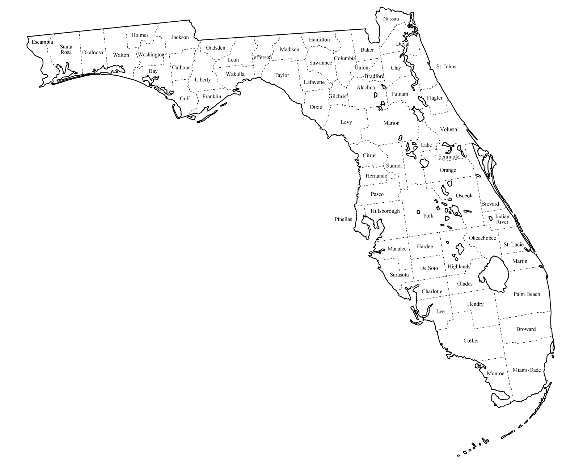
Tallahassee DMA
94%
Jacksonville DMA
93%

Ft. Myers-Naples DMA
94%
Palm Beach DMA 96%
Orlando DMA
86%
Gainesville DMA
90%
Panama City DMA 96%
Tampa DMA
97%
Ages 4-5; Restraint Use by DMA

The next figure shows the usage rate for children ages 4-5 by DMA. Again, the rates were determined using five years of data (2018–2022). Restraint use among this age group is universally lower compared than other age categories in the DMAs. Usage among passengers in this age category ranged from 67 percent to 90 percent. It is important to note here, that the broad range in usage rates across the DMAs is due, at least partially, to the low number of observations of four and five-year-old passengers. Still, the fact remains, passengers in this age category are restrained less often compared to the youngest age group and that is true across the entire State of Florida.

AGES 4-5
CHILD RESTRAINT USE BY DESIGNATED MARKET AREA (DMA)
FIVE YEAR AVERAGE (2018-2022)

Pensacola DMA
85%
Miami DMA 68%
Tallahassee DMA
67%
Jacksonville DMA
81%
Ft. Myers-Naples DMA
90%
Palm Beach DMA 69%
Orlando DMA
75%
Panama City DMA 81%
Tampa DMA
84%
Gainesville DMA
69%
Ages 6-12; Restraint Use by DMA

The next figure shows the usage rate for children ages 6-12 by DMA, once again using five years of data (2018–2022). Most of the passengers in this age group were observed out of child restraint devices and were observed either belted or not. Though more half still ride in the rear, many more of the passengers in this age group, compared to younger passengers, were observed riding in the front seat. Restraint usage for passengers ages 6-12 ranged from 67 percent to 90 percent across the ten DMAs. In this instance, the wide range in usage cannot be explained by low observation volume and is more likely due to area differences. Usage reached 90 percent in only one DMA (Pensacola), while only three DMAs had usage between 80 and 89 percent (Jacksonville, Panama City, and Tallahassee). Usage was between 70 percent to 79 in four DMAs (Ft. Myers–Naples, Gainesville, Orlando, and Tampa). Usage was below 70 percent in two DMAs (Miami and Palm Beach).

AGES 6-12
CHILD RESTRAINT USE BY DESIGNATED MARKET AREA (DMA)
FIVE YEAR AVERAGE (2018-2022)
Pensacola DMA
90%
Tallahassee DMA
89%
Orlando DMA
77%
Jacksonville DMA
80%
Palm Beach DMA 67%
Miami DMA 68%
Panama City DMA 87%
Gainesville DMA
76%
Ft. Myers-Naples DMA
79%
Tampa DMA
71%

Appendix A.
DMA County Specific Information

PENSACOLA DMA
Escambia County Suvey Locations  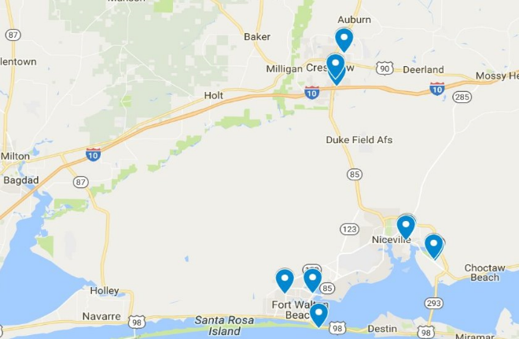 | Okaloosa County Survey Locations  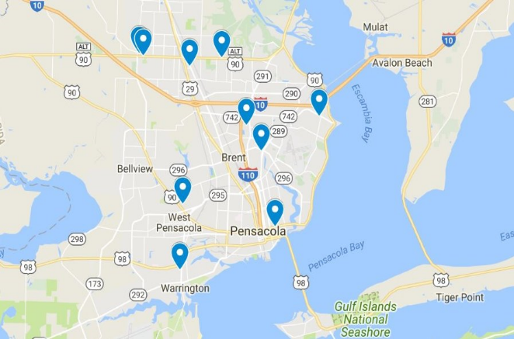

DMA | County | Age  0-3 | Age  4-5 | Age  6-12 | Unk.  Age | County Total | DMA  Total | RESTRAINT USE BY AGE  5 year averages
 |  |  |  |  |  |  |  | 0-3 | 4-5 | <6 | 6-12
Pensacola | Escambia | 501 | 65 | 629 | 0 | 1195 | 2844 | 99% | 89% | 97% | 90%
Pensacola | Okaloosa | 711 | 89 | 848 | 1 | 1649 | 2844 | 100% | 80% | 98% | 91%

PANAMA CITY DMA

Walton County Suvey Locations  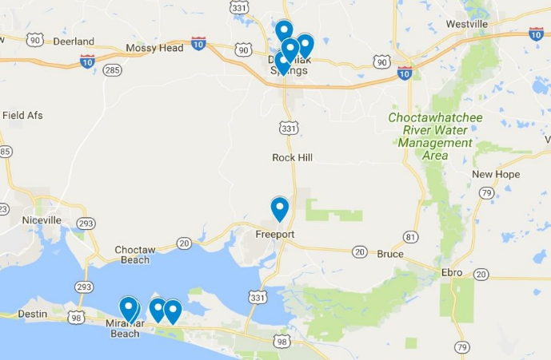 | Bay County Survey Locations  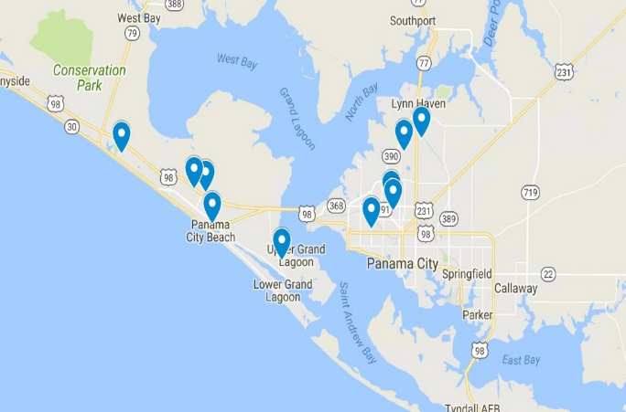

DMA | County | Age  0-3 | Age  4-5 | Age  6-12 | Unk.  Age | County Total | DMA  Total | RESTRAINT USE BY AGE  5 year averages
 |  |  |  |  |  |  |  | 0-3 | 4-5 | <6 | 6-12
Panama City | Walton | 294 | 75 | 503 | 1 | 873 | 1780 | 95% | 83% | 91% | 86%
Panama City | Bay | 326 | 86 | 495 | 0 | 907 | 1780 | 96% | 79% | 92% | 87%
TALLAHASSEE DMA

Leon County Survey Locations  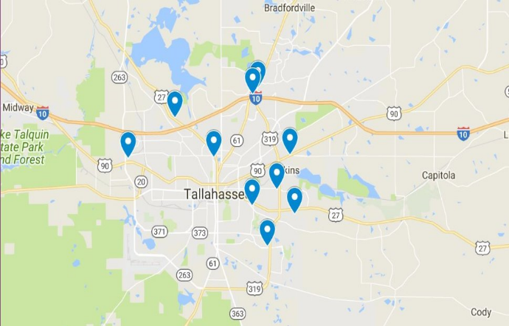 | Gadsden County Survey Locations  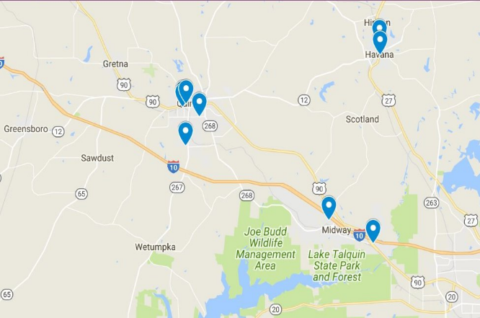

DMA | County | Age  0-3 | Age  4-5 | Age  6-12 | Unk.  Age | County Total | DMA  Total | RESTRAINT USE BY AGE  5 year averages
 |  |  |  |  |  |  |  | 0-3 | 4-5 | <6 | 6-12
Tallahassee | Gadsden | 233 | 75 | 441 | 0 | 749 | 2098 | 91% | 52% | 82% | 84%
Tallahassee | Leon | 528 | 106 | 711 | 4 | 1349 | 2098 | 98% | 83% | 96% | 94%

JACKSONVILLE DMA

Duval County Suvey Locations  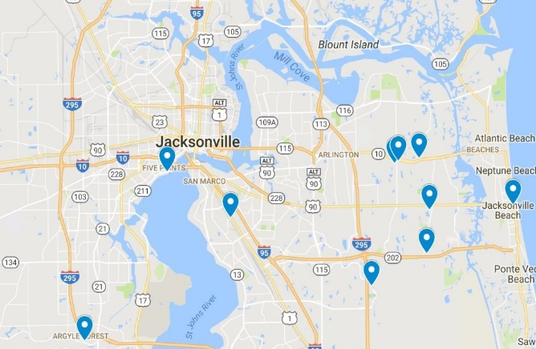 | Clay County Survey Locations  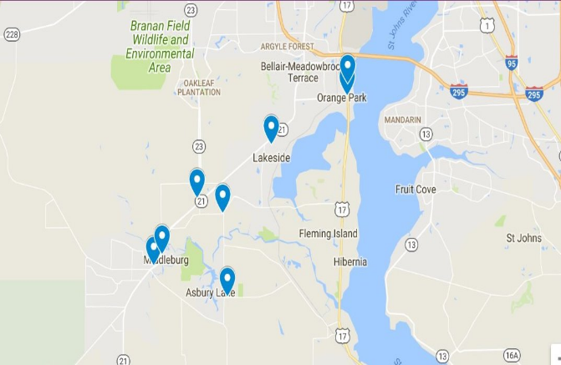

DMA | County | Age  0-3 | Age  4-5 | Age  6-12 | Unk.  Age | County Total | DMA  Total | RESTRAINT USE BY AGE  5 year averages
 |  |  |  |  |  |  |  | 0-3 | 4-5 | <6 | 6-12
Jacksonville | Clay | 347 | 294 | 429 | 0 | 1070 | 2094 | 95% | 81% | 88% | 79%
Jacksonville | Duval | 456 | 247 | 320 | 1 | 1024 | 2094 | 91% | 81% | 87% | 82%
GAINESVILLE DMA

Alachua County Suvey Locations  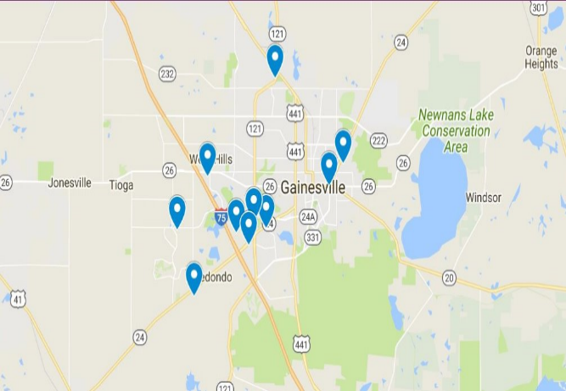 | Levy County Survey Locations  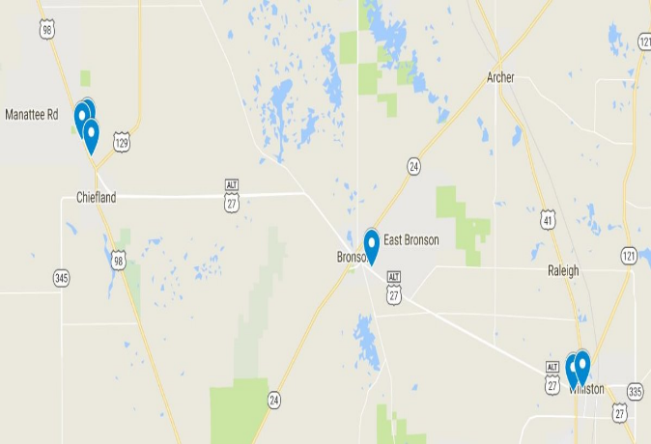

DMA | County | Age  0-3 | Age  4-5 | Age  6-12 | Unk.  Age | County Total | DMA  Total | RESTRAINT USE BY AGE  5 year averages
 |  |  |  |  |  |  |  | 0-3 | 4-5 | <6 | 6-12
Gainesville | Alachua | 429 | 276 | 307 | 0 | 1012 | 1934 | 90% | 73% | 84% | 80%
Gainesville | Levy | 238 | 261 | 423 | 0 | 922 | 1934 | 90% | 65% | 77% | 72%
ORLANDO DMA

Orange County Survey Locations  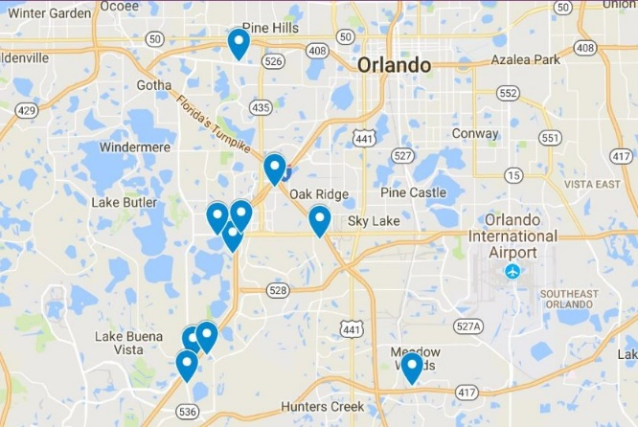 | Brevard County Survey Locations  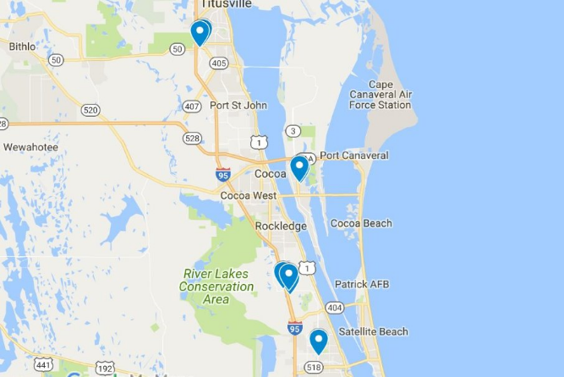

DMA | County | Age  0-3 | Age  4-5 | Age  6-12 | Unk.  Age | County Total | DMA  Total | RESTRAINT USE BY AGE  5 year averages
 |  |  |  |  |  |  |  | 0-3 | 4-5 | <6 | 6-12
Orlando | Orange | 570 | 492 | 603 | 0 | 1665 | 2892 | 81% | 72% | 77% | 76%
Orlando | Brevard | 521 | 302 | 403 | 1 | 1227 | 2892 | 92% | 78% | 87% | 79%
TAMPA DMA

Hillsborough County Survey Locations  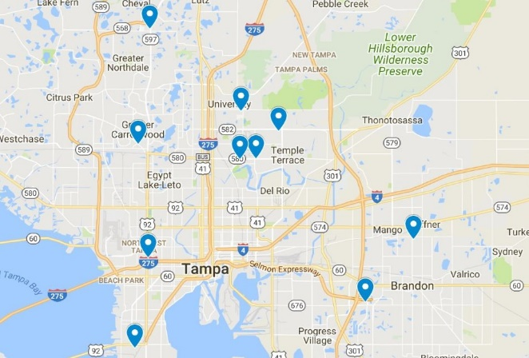 | Pinellas County Survey Locations  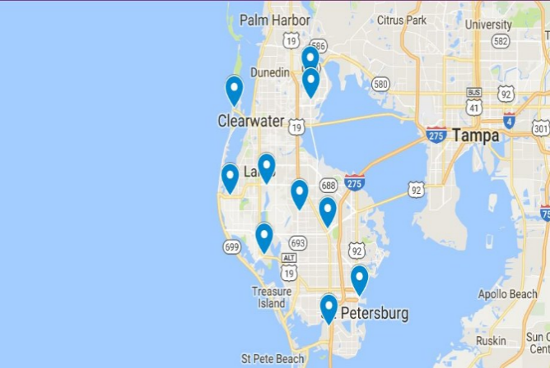

DMA | County | Age  0-3 | Age  4-5 | Age  6-12 | Unk.  Age | County Total | DMA  Total | RESTRAINT USE BY AGE  5 year averages
 |  |  |  |  |  |  |  | 0-3 | 4-5 | <6 | 6-12
Tampa | Pinellas | 125 | 323 | 697 | 1 | 1146 | 2392 | 99% | 84% | 88% | 71%
Tampa | Hillsborough | 107 | 319 | 820 | 0 | 1246 | 2392 | 96% | 84% | 87% | 71%

FT. MYERS-NAPLES DMA

Lee County Survey Locations  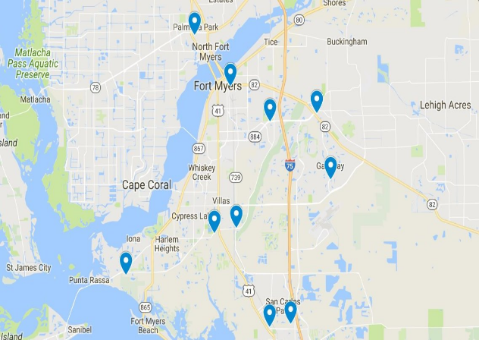 | Collier County Survey Location  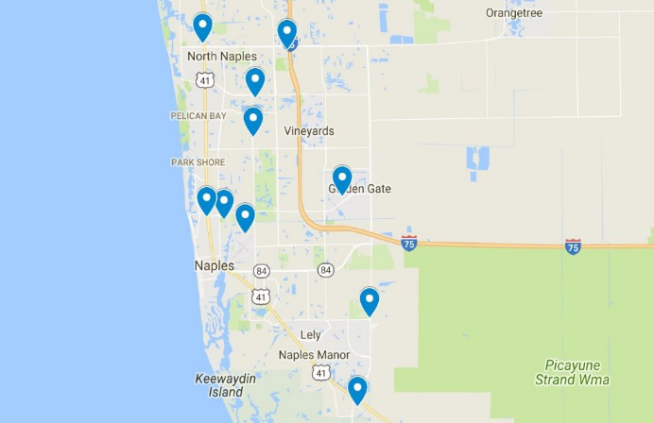

DMA | County | Age  0-3 | Age  4-5 | Age  6-12 | Unk.  Age | County Total | DMA  Total | RESTRAINT USE BY AGE  5 year averages
 |  |  |  |  |  |  |  | 0-3 | 4-5 | <6 | 6-12
Ft. Myers-Naples | Lee | 124 | 444 | 687 | 1 | 1256 | 2332 | 92% | 89% | 90% | 77%
Ft. Myers-Naples | Collier | 111 | 392 | 572 | 1 | 1076 | 2332 | 95% | 91% | 92% | 81%

PALM BEACH DMA

Palm Beach County Survey Locations  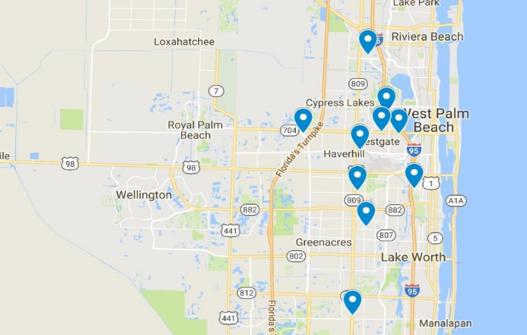 | St. Lucie County Survey Locations  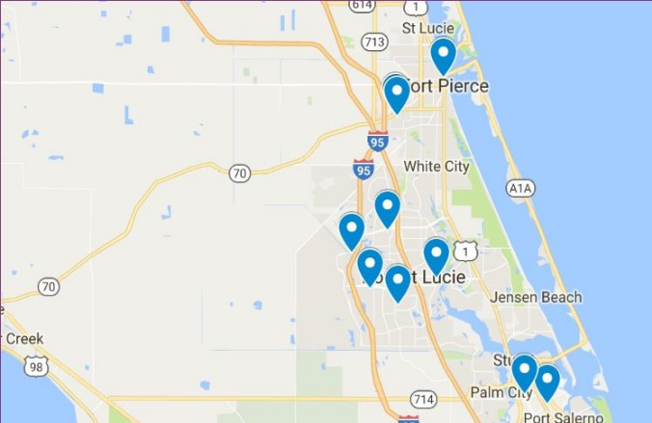

DMA | County | Age  0-3 | Age  4-5 | Age  6-12 | Unk.  Age | County Total | DMA  Total | RESTRAINT USE BY AGE  5 year averages
 |  |  |  |  |  |  |  | 0-3 | 4-5 | <6 | 6-12
Palm Beach | St. Lucie | 530 | 417 | 708 | 4 | 1659 | 3484 | 98% | 68% | 86% | 70%
Palm Beach | Palm Beach | 504 | 470 | 841 | 10 | 1825 | 3484 | 94% | 70% | 83% | 63%
MIAMI DMA

Miami-Dade County Survey Locations  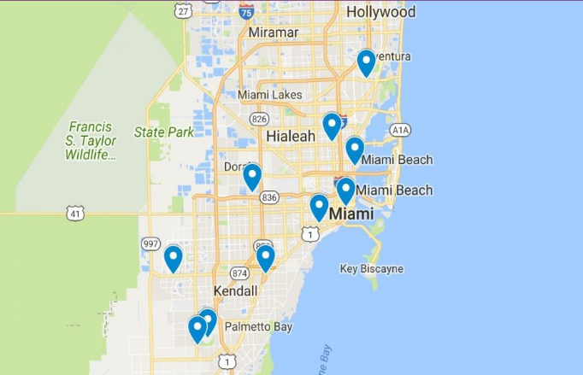 | Broward County Survey Locations  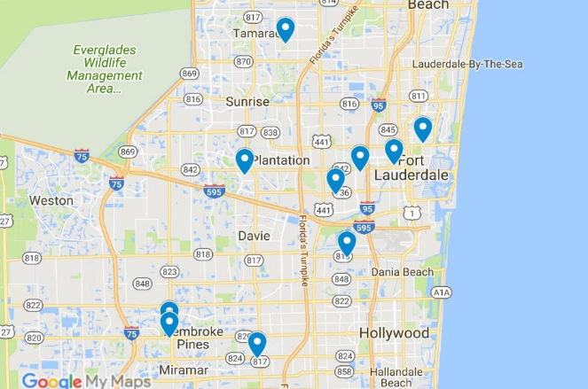

DMA | County | Age  0-3 | Age  4-5 | Age  6-12 | Unk.  Age | County Total | DMA  Total | RESTRAINT USE BY AGE  5 year averages
 |  |  |  |  |  |  |  | 0-3 | 4-5 | <6 | 6-12
Miami | Broward | 602 | 352 | 545 | 7 | 1506 | 2957 | 97% | 67% | 86% | 68%
Miami | Dade | 524 | 329 | 594 | 4 | 1451 | 2957 | 95% | 69% | 85% | 68%

Appendix B.
Number of Children Observed and Restraint Use by DMA and Age Category

NUMBER OF OBSERVED CHILDREN PER COUNTY AND DMA BY AGE CATEGORY
2022
DMA | County | Age  0-3 | Age  4-5 | Age  6-12 | Age  Unk. | County Total | DMA  Total | Restraint Use by Age Category
 |  |  |  |  |  |  |  | 0-3 | 4-5 | <6 | 6-12
Pensacola | Escambia | 132 | 20 | 144 | 0 | 296 | 713 | 99% | 80% | 96% | 92%
Pensacola | Okaloosa | 169 | 17 | 231 | 0 | 417 | 713 | 100% | 65% | 97% | 92%
Panama City | Walton | 141 | 12 | 228 | 0 | 381 | 690 | 98% | 83% | 97% | 90%
Panama City | Bay | 123 | 11 | 175 | 0 | 309 | 690 | 100% | 82% | 99% | 89%
Tallahassee | Gadsden | 49 | 18 | 113 | 0 | 180 | 500 | 96% | 67% | 88% | 79%
Tallahassee | Leon | 134 | 23 | 163 | 0 | 320 | 500 | 99% | 78% | 96% | 95%
Jacksonville | Clay | 85 | 54 | 63 | 0 | 202 | 444 | 91% | 78% | 86% | 62%
Jacksonville | Duval | 95 | 55 | 92 | 0 | 224 | 444 | 92% | 71% | 84% | 76%
Gainesville | Alachua | 75 | 60 | 68 | 0 | 203 | 339 | 89% | 78% | 84% | 71%
Gainesville | Levy | 30 | 35 | 71 | 0 | 136 | 339 | 83% | 54% | 68% | 63%
Orlando | Orange | 84 | 70 | 115 | 0 | 269 | 477 | 85% | 66% | 86% | 62%
Orlando | Brevard | 80 | 50 | 78 | 0 | 208 | 477 | 91% | 78% | 84% | 76%
Tampa | Pinellas | 17 | 61 | 159 | 0 | 237 | 494 | 100% | 85% | 89% | 70%
Tampa | Hillsborough | 23 | 56 | 178 | 0 | 257 | 494 | 100% | 93% | 95% | 65%
Palm Beach | St. Lucie | 104 | 53 | 136 | 0 | 293 | 605 | 99% | 60% | 86% | 60%
Palm Beach | Palm Beach | 110 | 77 | 125 | 0 | 312 | 605 | 94% | 57% | 79% | 54%
Ft. Myers-Naples | Lee | 30 | 89 | 152 | 0 | 271 | 498 | 97% | 96% | 96% | 80%
Ft. Myers-Naples | Collier | 36 | 64 | 127 | 0 | 227 | 498 | 100% | 95% | 97% | 80%
Miami | Broward | 114 | 75 | 124 | 0 | 340 | 611 | 97% | 64% | 85% | 61%
Miami | Dade | 115 | 65 | 91 | 0 | 271 | 611 | 94% | 62% | 82% | 60%
Total |  | 1773 | 965 | 2633 | 0 | 5371 | 5371

NUMBER OF OBSERVED CHILDREN PER COUNTY AND DMA BY AGE CATEGORY
2021
DMA | County | Age  0-3 | Age  4-5 | Age  6-12 | Age  Unk. | County Total | DMA  Total | Restraint Use by Age Category
 |  |  |  |  |  |  |  | 0-3 | 4-5 | <6 | 6-12
Pensacola | Escambia | 102 | 15 | 136 | 0 | 253 | 620 | 100% | 93% | 99% | 92%
Pensacola | Okaloosa | 167 | 22 | 178 | 0 | 367 | 620 | 100% | 82% | 98% | 94%
Panama City | Walton | 55 | 4 | 80 | 0 | 139 | 318 | 100% | 100% | 100% | 95%
Panama City | Bay | 70 | 17 | 92 | 0 | 179 | 318 | 99% | 94% | 98% | 93%
Tallahassee | Gadsden | 46 | 11 | 104 | 0 | 161 | 430 | 98% | 45% | 88% | 85%
Tallahassee | Leon | 99 | 14 | 156 | 0 | 269 | 430 | 99% | 93% | 98% | 96%
Jacksonville | Clay | 133 | 91 | 82 | 0 | 306 | 593 | 89% | 76% | 84% | 76%
Jacksonville | Duval | 139 | 81 | 67 | 0 | 287 | 593 | 94% | 80% | 89% | 76%
Gainesville | Alachua | 116 | 75 | 36 | 0 | 227 | 443 | 84% | 79% | 82% | 92%
Gainesville | Levy | 61 | 80 | 75 | 0 | 216 | 443 | 95% | 66% | 79% | 68%
Orlando | Orange | 147 | 132 | 95 | 0 | 374 | 585 | 80% | 81% | 81% | 77%
Orlando | Brevard | 111 | 53 | 47 | 0 | 211 | 585 | 96% | 81% | 91% | 72%
Tampa | Pinellas | 30 | 98 | 131 | 0 | 259 | 530 | 100% | 86% | 89% | 74%
Tampa | Hillsborough | 33 | 117 | 121 | 0 | 271 | 530 | 94% | 85% | 87% | 75%
Palm Beach | St. Lucie | 140 | 109 | 159 | 2 | 410 | 803 | 97% | 72% | 86% | 60%
Palm Beach | Palm Beach | 115 | 107 | 169 | 2 | 393 | 803 | 95% | 62% | 79% | 66%
Ft. Myers-Naples | Lee | 32 | 119 | 152 | 0 | 303 | 571 | 84% | 83% | 83% | 70%
Ft. Myers-Naples | Collier | 12 | 111 | 145 | 0 | 268 | 571 | 92% | 91% | 91% | 72%
Miami | Broward | 124 | 70 | 102 | 1 | 297 | 579 | 98% | 80% | 92% | 65%
Miami | Dade | 93 | 71 | 117 | 1 | 282 | 579 | 92% | 75% | 85% | 68%
Total |  | 1825 | 1397 | 2244 | 6 | 5472 | 5472

Number of Observed Children per County and DMA by Age Category
2020
DMA | County | Age  0-3 | Age  4-5 | Age  6-12 | Age  Unk. | County Total | DMA  Total | Restraint Use by Age Category
 |  |  |  |  |  |  |  | 0-3 | 4-5 | <6 | 6-12
Pensacola | Escambia | 68 | 9 | 114 | 0 | 191 | 500 | 97% | 100% | 97% | 89%
Pensacola | Okaloosa | 108 | 26 | 175 | 0 | 309 | 500 | 100% | 96% | 99% | 89%
Panama City | Walton | 47 | 11 | 88 | 0 | 146 | 324 | 98% | 91% | 97% | 91%
Panama City | Bay | 62 | 15 | 101 | 0 | 178 | 324 | 98% | 80% | 95% | 92%
Tallahassee | Gadsden | 46 | 11 | 81 | 0 | 138 | 331 | 87% | 45% | 79% | 85%
Tallahassee | Leon | 71 | 13 | 108 | 1 | 193 | 331 | 99% | 85% | 96% | 96%
Jacksonville | Clay | 42 | 80 | 107 | 0 | 229 | 419 | 100% | 76% | 84% | 91%
Jacksonville | Duval | 64 | 55 | 71 | 0 | 190 | 419 | 92% | 80% | 87% | 82%
Gainesville | Alachua | 56 | 36 | 43 | 0 | 135 | 303 | 91% | 69% | 83% | 81%
Gainesville | Levy | 36 | 52 | 80 | 0 | 168 | 303 | 92% | 69% | 78% | 75%
Orlando | Orange | 36 | 57 | 79 | 0 | 172 | 361 | 72% | 74% | 73% | 82%
Orlando | Brevard | 73 | 44 | 72 | 0 | 189 | 361 | 89% | 80% | 85% | 76%
Tampa | Pinellas | 30 | 53 | 159 | 0 | 242 | 474 | 100% | 83% | 89% | 66%
Tampa | Hillsborough | 13 | 26 | 193 | 0 | 232 | 474 | 92% | 85% | 87% | 68%
Palm Beach | St. Lucie | 130 | 66 | 107 | 2 | 305 | 597 | 98% | 53% | 83% | 73%
Palm Beach | Palm Beach | 87 | 55 | 144 | 6 | 292 | 597 | 91% | 76% | 85% | 64%
Ft. Myers-Naples | Lee | 14 | 65 | 144 | 0 | 223 | 407 | 79% | 98% | 95% | 61%
Ft. Myers-Naples | Collier | 15 | 60 | 108 | 1 | 184 | 407 | 93% | 92% | 92% | 74%
Miami | Broward | 94 | 32 | 100 | 2 | 228 | 462 | 99% | 59% | 89% | 78%
Miami | Dade | 90 | 40 | 102 | 2 | 234 | 462 | 93% | 65% | 85% | 67%
Total |  | 1182 | 806 | 2176 | 14 | 4178 | 4178

Number of Observed Children per County and DMA by Age Category
2019
DMA | County | Age  0-3 | Age  4-5 | Age  6-12 | Age  Unk. | County Total | DMA  Total | Restraint Use by Age Category
 |  |  |  |  |  |  |  | 0-3 | 4-5 | <6 | 6-12
Pensacola | Escambia | 101 | 10 | 117 | 0 | 228 | 513 | 100% | 100% | 100% | 91%
Pensacola | Okaloosa | 138 | 11 | 136 | 0 | 285 | 513 | 99% | 82% | 97% | 92%
Panama City | Walton | 22 | 23 | 48 | 0 | 93 | 202 | 86% | 78% | 82% | 77%
Panama City | Bay | 31 | 18 | 60 | 0 | 109 | 202 | 97% | 67% | 86% | 80%
Tallahassee | Gadsden | 40 | 12 | 70 | 0 | 122 | 379 | 85% | 42% | 75% | 79%
Tallahassee | Leon | 108 | 20 | 129 | 0 | 257 | 379 | 98% | 75% | 95% | 91%
Jacksonville | Clay | 45 | 29 | 59 | 0 | 133 | 253 | 96% | 79% | 89% | 80%
Jacksonville | Duval | 61 | 22 | 37 | 0 | 120 | 253 | 87% | 86% | 87% | 89%
Gainesville | Alachua | 104 | 39 | 75 | 0 | 218 | 385 | 91% | 59% | 83% | 71%
Gainesville | Levy | 40 | 38 | 89 | 0 | 167 | 385 | 85% | 63% | 74% | 67%
Orlando | Orange | 151 | 105 | 152 | 0 | 408 | 693 | 79% | 64% | 73% | 72%
Orlando | Brevard | 116 | 69 | 100 | 0 | 285 | 693 | 92% | 75% | 86% | 79%
Tampa | Pinellas | 14 | 48 | 126 | 1 | 189 | 438 | 93% | 79% | 82% | 67%
Tampa | Hillsborough | 16 | 55 | 178 | 0 | 249 | 438 | 100% | 84% | 87% | 73%
Palm Beach | St. Lucie | 113 | 92 | 144 | 0 | 349 | 779 | 98% | 73% | 87% | 76%
Palm Beach | Palm Beach | 142 | 119 | 168 | 1 | 430 | 779 | 100% | 77% | 90% | 65%
Ft. Myers-Naples | Lee | 16 | 74 | 124 | 1 | 215 | 416 | 100% | 85% | 88% | 83%
Ft. Myers-Naples | Collier | 12 | 70 | 119 | 0 | 201 | 416 | 92% | 90% | 90% | 87%
Miami | Broward | 172 | 69 | 117 | 2 | 360 | 715 | 95% | 64% | 86% | 66%
Miami | Dade | 156 | 64 | 134 | 1 | 355 | 715 | 96% | 70% | 88% | 67%
Total |  | 1598 | 987 | 2182 | 6 | 4773 | 4773

Number of Observed Children per County and DMA by Age Category
2018
DMA | County | Age  0-3 | Age  4-5 | Age  6-12 | Age  Unk. | County Total | DMA  Total | Restraint Use by Age Category
 |  |  |  |  |  |  |  | 0-3 | 4-5 | <6 | 6-12
Pensacola | Escambia | 98 | 11 | 118 | 0 | 227 | 498 | 97% | 73% | 94% | 83%
Pensacola | Okaloosa | 129 | 13 | 128 | 1 | 271 | 498 | 99% | 77% | 97% | 90%
Panama City | Walton | 29 | 25 | 59 | 1 | 114 | 246 | 93% | 64% | 80% | 76%
Panama City | Bay | 40 | 25 | 67 | 0 | 132 | 246 | 88% | 72% | 82% | 82%
Tallahassee | Gadsden | 52 | 23 | 73 | 0 | 148 | 458 | 88% | 61% | 80% | 93%
Tallahassee | Leon | 116 | 36 | 155 | 3 | 310 | 458 | 96% | 83% | 93% | 90%
Jacksonville | Clay | 42 | 40 | 118 | 0 | 200 | 385 | 100% | 95% | 98% | 85%
Jacksonville | Duval | 97 | 34 | 53 | 1 | 185 | 385 | 92% | 88% | 91% | 85%
Gainesville | Alachua | 78 | 66 | 85 | 0 | 229 | 464 | 95% | 79% | 88% | 86%
Gainesville | Levy | 71 | 56 | 108 | 0 | 235 | 464 | 94% | 73% | 85% | 85%
Orlando | Orange | 152 | 128 | 162 | 0 | 442 | 776 | 88% | 74% | 81% | 82%
Orlando | Brevard | 141 | 86 | 106 | 1 | 334 | 776 | 91% | 75% | 85% | 85%
Tampa | Pinellas | 34 | 63 | 122 | 0 | 219 | 456 | 100% | 87% | 92% | 76%
Tampa | Hillsborough | 22 | 65 | 150 | 0 | 237 | 456 | 95% | 75% | 80% | 73%
Palm Beach | St. Lucie | 43 | 97 | 162 | 0 | 302 | 700 | 98% | 80% | 86% | 80%
Palm Beach | Palm Beach | 50 | 112 | 235 | 1 | 398 | 700 | 92% | 79% | 83% | 69%
Ft. Myers-Naples | Lee | 32 | 97 | 115 | 0 | 244 | 440 | 100% | 84% | 88% | 88%
Ft. Myers-Naples | Collier | 36 | 87 | 73 | 0 | 196 | 440 | 100% | 89% | 92% | 93%
Miami | Broward | 71 | 106 | 102 | 2 | 281 | 590 | 97% | 69% | 79% | 72%
Miami | Dade | 70 | 89 | 150 | 0 | 309 | 590 | 100% | 73% | 85% | 80%
Total |  | 1403 | 1259 | 2341 | 10 | 5013 | 5013

Number of Observed Children per County and DMA by Age Category
2017
DMA | County | Age  0-3 | Age  4-5 | Age  6-12 | Age  Unk. | County Total | DMA  Total | Restraint Use by Age Category
 |  |  |  |  |  |  |  | 0-3 | 4-5 | <6 | 6-12
Pensacola | Escambia | 100 | 38 | 84 | 2 | 224 | 493 | 97% | 89% | 95% | 82%
Pensacola | Okaloosa | 149 | 39 | 80 | 1 | 269 | 493 | 99% | 82% | 95% | 93%
Panama City | Walton | 32 | 35 | 82 | 3 | 152 | 327 | 100% | 80% | 90% | 73%
Panama City | Bay | 56 | 38 | 79 | 2 | 175 | 327 | 98% | 82% | 91% | 73%
Tallahassee | Gadsden | 82 | 26 | 46 | 2 | 156 | 461 | 90% | 49% | 80% | 83%
Tallahassee | Leon | 164 | 41 | 98 | 2 | 305 | 461 | 99% | 83% | 96% | 95%
Jacksonville | Clay | 64 | 45 | 84 | 5 | 198 | 371 | 97% | 89% | 94% | 89%
Jacksonville | Duval | 61 | 43 | 65 | 4 | 173 | 371 | 97% | 91% | 94% | 90%
Gainesville | Alachua | 95 | 74 | 53 | 7 | 229 | 477 | 87% | 74% | 82% | 77%
Gainesville | Levy | 57 | 83 | 102 | 6 | 248 | 477 | 91% | 54% | 69% | 70%
Orlando | Orange | 186 | 184 | 137 | 2 | 509 | 831 | 85% | 68% | 77% | 73%
Orlando | Brevard | 133 | 110 | 76 | 3 | 322 | 831 | 87% | 75% | 81% | 71%
Tampa | Pinellas | 62 | 89 | 124 | 4 | 279 | 567 | 98% | 90% | 93% | 96%
Tampa | Hillsborough | 55 | 79 | 152 | 2 | 288 | 567 | 98% | 97% | 98% | 93%
Palm Beach | St. Lucie | 100 | 69 | 134 | 14 | 317 | 718 | 99% | 77% | 90% | 81%
Palm Beach | Palm Beach | 97 | 96 | 197 | 11 | 401 | 718 | 99% | 77% | 88% | 82%
Ft. Myers-Naples | Lee | 42 | 67 | 102 | 0 | 211 | 423 | 100% | 100% | 100% | 94%
Ft. Myers-Naples | Collier | 34 | 57 | 121 | 0 | 212 | 423 | 100% | 96% | 98% | 99%
Miami | Broward | 131 | 55 | 128 | 10 | 324 | 562 | 95% | 67% | 87% | 82%
Miami | Dade | 70 | 35 | 128 | 5 | 238 | 562 | 93% | 60% | 82% | 76%
Total |  | 1770 | 1303 | 2072 | 85 | 5230 | 5230

Appendix C.
Data Collection Form

FLORIDA Child Restraint Use Data Collection Form 2017 - SAMPLE
SITE #: _____________ COUNTY: ____________________________ Observer Name: ____________________ DATE: __________________
TIME: ____________ a.m. p.m. DAY OF WEEK: Sun M Tu W Th F Sat DIRECTION OF TRAVEL: N S E W
(circle one) (circle one)
LOCATION:____________________________________________________________________________________________________________
 |  | (street) |  | (cross street or other landmark)
SITE TYPE: 1-Daycare Facility 2-Food Establishment 3-Shopping Center/Grocery Store 4- Entertainment/Recreation place
(circle one)
 SAME VEHICLE AS PREVIOUS |  |  |  | ❒ OBSERVED ON ADJACENT STREET
VEHICLE TYPE: | DRIVER
VEHICLE TYPE: | RESTRAINT USE: |  | AGE: | GENDER: | RACE:
Passenger Car SUV | Belted Unk |  | 16-34 60+ | Male Female | White | Hispanic |  | Unk
Van/Minivan Pickup Truck | Not Belted |  | 35-59 Unk | Unk | Black | Other
  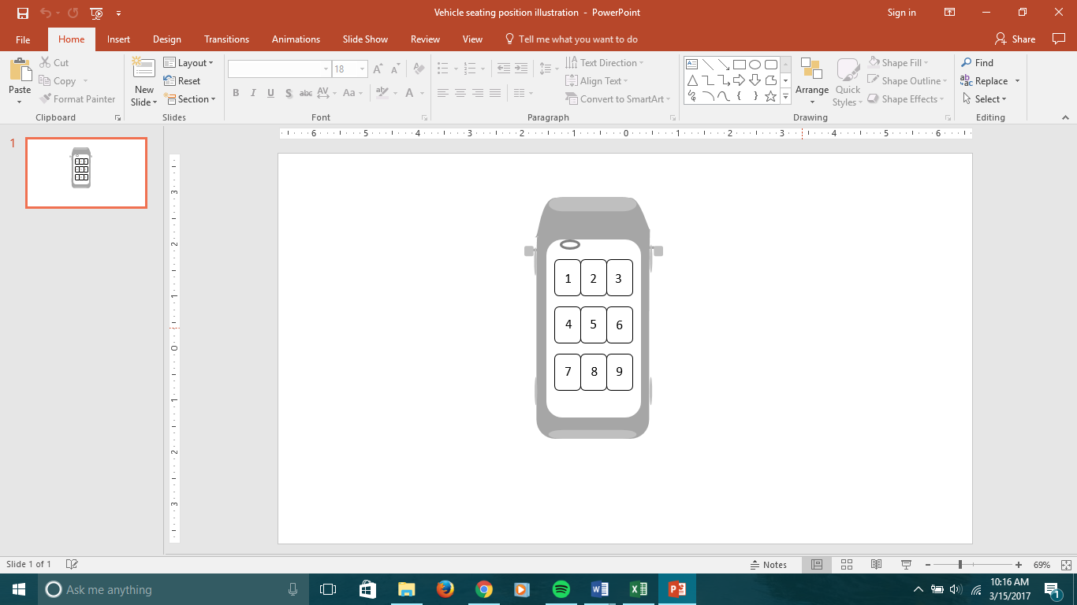
  CHILD PASSENGER 1
  CHILD PASSENGER 2
RESTRAINT USE: |  | AGE: |  | RESTRAINT USE: |  | AGE:
Standard Belt Backless Booster |  | 0-3 4-5 |  | Standard Belt Backless Booster |  | 0-34-5
Rear-Facing CSS Not Belted |  | 6-12 |  | Rear-Facing CSS Not Belted |  | 6-12
Front-Facing CSS Unk |  |  |  | Front-Facing CSS Unk
High Back Booster |  |  | Seating Position | High Back Booster |  |  | Seating Position
 SAME VEHICLE AS PREVIOUS |  |  |  | ❒ OBSERVED ON ADJACENT STREET
VEHICLE TYPE: | DRIVER
VEHICLE TYPE: | RESTRAINT USE: |  | AGE: | GENDER: | RACE:
Passenger Car SUV | Belted Unk |  | 16-34 60+ | Male Female | White | Hispanic |  | Unk
Van/Minivan Pickup Truck | Not Belted |  | 35-59 Unk | Unk | Black | Other
  CHILD PASSENGER 1
  CHILD PASSENGER 2
RESTRAINT USE: |  | AGE: |  | RESTRAINT USE: |  | AGE:
Standard Belt Backless Booster |  | 0-3 4-5 |  | Standard Belt Backless Booster |  | 0-3 4-5
Rear-Facing CSS Not Belted |  | 6-12 |  | Rear-Facing CSS Not Belted |  | 6-12
Front-Facing CSS Unk |  |  |  | Front-Facing CSS Unk
High Back Booster |  |  | Seating Position | High Back Booster |  |  | Seating Position
 SAME VEHICLE AS PREVIOUS |  |  |  | ❒ OBSERVED ON ADJACENT STREET
VEHICLE TYPE: | DRIVER
VEHICLE TYPE: | RESTRAINT USE: |  | AGE: | GENDER: | RACE:
Passenger Car SUV | Belted Unk |  | 16-34 60+ | Male Female | White | Hispanic |  | Unk
Van/Minivan Pickup Truck | Not Belted |  | 35-59 Unk | Unk | Black | Other
  CHILD PASSENGER 1
  CHILD PASSENGER 2
RESTRAINT USE: |  | AGE: |  | RESTRAINT USE: |  | AGE:
Standard Belt Backless Booster |  | 0-3 4-5 |  | Standard Belt Backless Booster |  | 0-34-5
Rear-Facing CSS Not Belted |  | 6-12 |  | Rear-Facing CSS Not Belted |  | 6-12
Front-Facing CSS Unk |  |  |  | Front-Facing CSS Unk
High Back Booster |  |  | Seating Position | High Back Booster |  |  | Seating Position

Preusser Research Group, Inc. employees.
Fewer than 10 pins showing because of overlapping pins, or some site(s) used twice on different day of week and time of day.
Fewer than 10 pins showing because of overlapping pins, or some site(s) used twice on different day of week and time of day.
Fewer than 10 pins showing because of overlapping pins, or some site(s) used twice on different day of week and time of day.
Fewer than 10 pins showing because of overlapping pins, or some site(s) used twice on different day of week and time of day.
Fewer than 10 pins showing because of overlapping pins, or some site(s) used twice on different day of week and time of day.
Fewer than 10 pins showing because of overlapping pins, or some site(s) used twice on different day of week and time of day.
Fewer than 10 pins showing because of overlapping pins, or some site(s) used twice on different day of week and time of day.
Fewer than 10 pins showing because of overlapping pins, or some site(s) used twice on different day of week and time of day.

