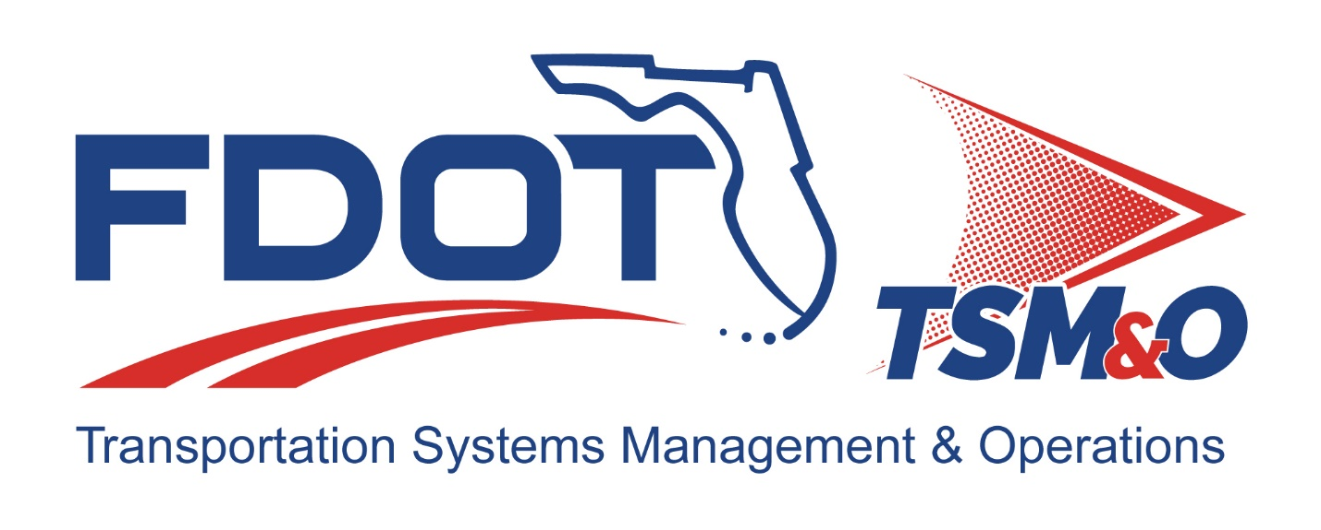

Form FM-SE-07

Program Management Plan
TEMPLATE

TEMPLATE Version:

TEMPLATE Approval Date:

Procedure for Using this Template to Create a Deliverable:
- Enter your name, firm, and date in the Author Field Document control panel.
- Replace [bracketed text] and empty sections with your project information and/or document content.
Note that bracketed text in blue italics is surrounded by brackets, using the document’s font, with the instructions on the content with which to replace the instructions. When you remove or highlight the entire bracketed portion and replace it with text, the text should appear in the desired text format of the document. Also, the Document Title is a property/field of the document visible from the file system and will appear differently than with blue italics and can utilize the “Update Field” functionality.
- Each section contains instructions preceded with a checkbox for that section in blue italics. Additional helpful information and description of the required content for that section will be indicated as well, next to the lightbulb icon .
- Some sections also contain boilerplate text to use as a starting point. Review and modify the boilerplate content, if it exists, and add additional content as necessary to fulfill the requirement of each section. Use the Styles H1 – H5 for section headers, Figure Caption for captions below figures, and Table Caption for captions above tables so that the Table of Contents, List of Figures, and List of Tables can be automatically updated.
- Define acronyms at the first usage in parenthesis after the expanded term and add to the “List of Acronyms” section.
- Delete the template title page, these instructions pages, all blue instructions, and the detailed instruction notes and examples that are identified with the lightbulb throughout the document.
- Update the file name and file location in the document control panel by right-clicking the field, then select “Update Field.”
- Update the Headers and Footers to have the appropriate document title and version.
- Delete the List of Tables or List of Figures if they do not contain any items.
- Update the Table of Contents, List of Tables, and List of Figures by right-clicking and selecting “Update Field,” and then select “Update entire table.”
- Have the document modified and reviewed as appropriate, and have each reviewer and modifier enter their name, organization, and date in the document control panel.
- Submit the document for approval and go through the review/revision needed to obtain approval to finalize the document.
- Repeat the review cycle and resubmit for approval as needed to obtain approval to finalize the document.
- Enter the approver’s name, organization, and date in the “Approved By” section of the document control panel.
- Enter the approval date on the title page and in the footer throughout the document and update the revision history at the end of the document.
- Remove the DRAFT watermark on the title page and the content pages by entering the Edit Header and Footer mode of the document and deleting the DRAFT image.
- Print the document to PDF and review it outside of the Microsoft Word application.
- Submit the Word and PDF versions of the document as the final documents.

Template Revision History

Version | Date | Name | Description
1.0 | Unknown | Unknown | Original template
1.1 | 6/14/2018 | Unknown | Updated FDOT logos on form
2.0 | 08/28/2024  09/04/2024  10/30/2024 | Amber Greene  Steve Bahler | Updated guidance format to match ConOps  Updated content to reference other SE documents

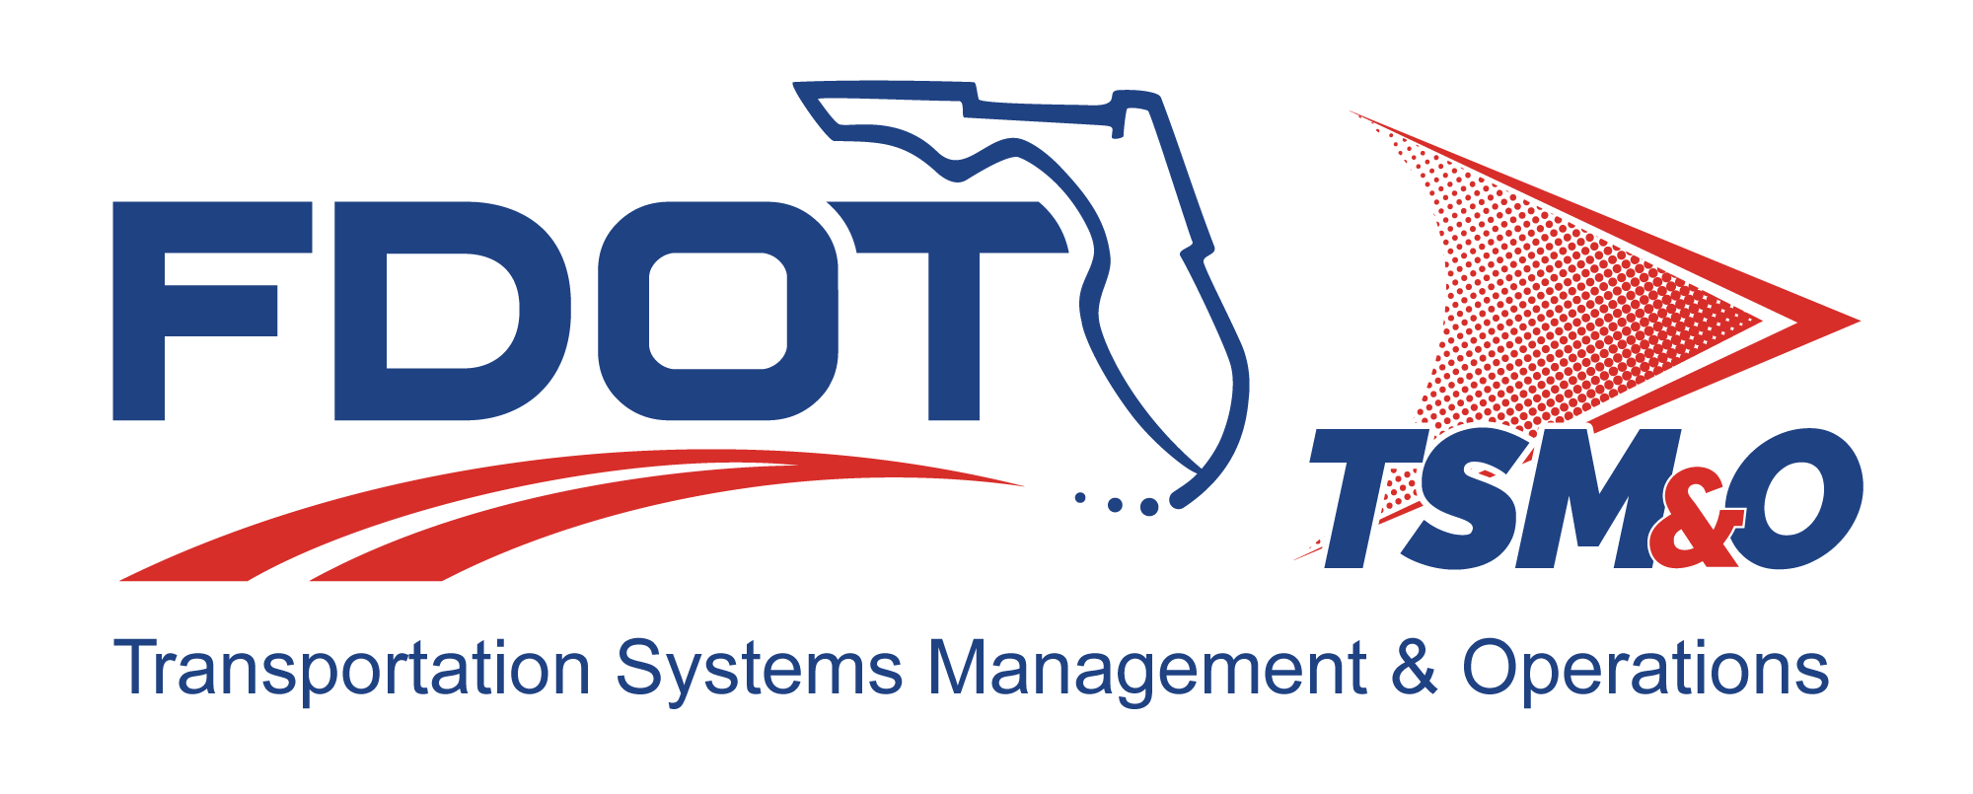

Program Management Plan for: insert project name

Version: insert version number

Approval date: insert approval date

DOCUMENT CONTROL PANEL
File Name: | [insert project file name]
File Location: | [insert project file URL]
Version Number: | [insert version #]
Name |  | Date
Created By: | [insert author name, organization] | [insert creation date]
Reviewed By: | [insert reviewer name, organization] | [insert review date]
Modified By: | [insert modifier name, organization] | [insert modified date]
Approved By: | [insert approver name, organization] | [insert approval date]
Table of Contents

1. Introduction 1
1.1 Project Information 1
1.2 Deliverables 1
1.2.1 System Description 1
1.2.2 Products and Services 1
1.3 Key Project Events 2
1.4 Goals 2
1.5 Vision and Charter 2
2. Project Organization 2
2.1 Organization Structure 2
2.2 Responsibilities 2
3. Management Plans 3
3.1 Statement of Work 3
3.2 Cost Management 3
3.3 Schedule Management 3
3.4 Technical Management 3
3.5 Resource Management 4
3.6 Risk Management 4
3.7 Subcontract Management 4
3.8 Configuration and Data Management 4
3.9 Quality Management 5
3.10 Monitoring and Control 5
4. Status Tracking 5
4.1 Reviews 6
4.2 Metrics 6
5. User Definitions 7

List of Tables

Table 1: Title 7

List of Figures

Figure 1: Title 7

List of Acronyms and Abbreviations

FDOT Florida Department of Transportation
ConOps Concept of Operations
CDMP Configuration Data Management Plan
HDP Hardware Development Plan
ITS Intelligent Transportation Systems
PMP Program Management Plan
P-SEMP Project Systems Engineering Management Plan
QMP Quality Management Plan
SDP Software Development Plan
SEMP Systems Engineering Management Plan
SOW Statement of Work

Introduction
- Include a summary of the purpose of the Project Management Plan (PMP). Modify the following paragraph as appropriate. A stand-along PMP may not be required if the contents are covered in the Project Systems Engineering Management Plan (P-SEMP).
The Program Management Plan (PMP) establishes the management approach used on [insert the Project Name] to ensure the intelligent transportation systems (ITS) project is consistent with the approach used on all Florida Department of Transportation (FDOT) ITS programs. The PMP describes the overall program structure; deliverables; related management plans and procedures; and the methods used to plan, monitor, control, and improve the project development efforts. The PMP is a dynamic document and is updated on a periodic basis to reflect all organizational changes, lessons learned, and advances in methodologies that occur throughout a project’s life cycle.

Project Information
This section provides a brief summary of the program and includes:
- Include summary information in the list, if applicable. Add other topics, if applicable.
- Project Name
- Contract Number
- Period of Performance
- Contract Type (i.e., firm fixed price, cost plus, etc.)
- Contract Value
- Delivery Date
- Project Manager
- Contact Information

Deliverables

System Description
- Provide a brief description of the system being developed and managed. Refer to other systems engineering documents, as necessary, the keep the description here brief.

Products and Services
- Provide a brief description of what products being supplied to FDOT for this project. Also, provide a list of products and services that will be produced by the project. Refer to other systems engineering documents, as necessary, to keep the description here brief.

Key Project Events
- Summarize the key milestone events for the project. For example, functional assessment events, acceptance/approval events, key technical demonstrations/collaborative events, etc. Refer to other systems engineering documents, as necessary, to keep the description here brief.

Goals
- Briefly describe any strategic and/or tactical goals the project is to achieve. These may include cost, schedule, or technical goals. Refer to other systems engineering documents, as necessary, to keep the description here brief.

Vision and Charter
- Briefly describe the project’s vision and charter. The purpose of a shared vision is to provide a statement of an envisioned future, and to establish a common understanding of the aspirations and governing ideals of the project. The charter is the contract among the project stakeholders for the expected work effort and level of performance. Refer to the Project Concept of Operations (ConOps), concept studies, or other systems engineering documents, as necessary, to keep the description here brief.

Project Organization

Organization Structure
- Describe the organizational structure of the project. The organization includes FDOT personnel, other agencies personnel, subcontractors, customers, and users. The description includes the role and involvement of each entity in the project. Refer to the ConOps, P-SEMP, or other systems engineering documents, as appropriate.

Responsibilities
- Describe the roles and responsibilities of key project personnel listed below. Adjust the list as appropriate for the project. Add other key stakeholders, as needed. Refer to the ConOps, P-SEMP, or other systems engineering documents, as appropriate.

- Project Manager
- Subcontracts Manager
- Project Engineer
- Finance Manager
- Planning
- Operation
- Procurement
- Configuration Management
- Quality Assurance

Management Plans
- Describe management plans that are part of the project development and implementation. Adjust the managements as appropriate for the project. Refer to the ConOps, P-SEMP, or other systems engineering documents, as appropriate, to minimize duplication of effort.

Statement of Work
- The statement of work (SOW) defines the planning and management activities for the project. The SOW is mutually agreed to by the key stakeholders and FDOT project management. The SOW resides in the project library and is maintained by the project manager.

Cost Management
- Describe internal cost management policies that provide a set of operating procedures for planning, directing, monitoring, and measuring work. These policies provide controls for accurate decision-making data for the project management team to analyze, capture variances, and plan revisions to the baseline costs.

Schedule Management
- Provide an integrated master schedule in sufficient detail to define resource requirements, material timing, and integration requirements with existing plans and schedules. The integrated master schedule, built around the contract work breakdown structure, is the top level of the scheduling system, and is supported by a hierarchy of intermediate and detailed schedules. All critical dependencies, resources needed, and critical path items are clearly identified on the integrated master schedule.

Technical Management
- Modify the following paragraph as appropriate.
Technical management plans have been prepared for this high risk and complex project. (See FDOT’s Systems Engineering and ITS Architecture Procedure for additional information on FDOT’s tailored systems engineering analysis process.) These documents reside in the project library and are maintained by the project engineer. The technical management strategy for the project is documented in the following management plans:
- List key management plans for this project. Since these plans are typically stand-alone documents, refer to the specific document and filename for each plan applicable to the project.
- Project Systems Engineering Management Plan (P-SEMP) – This plan describes the overall plans for the engineering and implementation of the project. The P-SEMP should also describe how the technical baselines (e.g., requirements, specifications, etc.) for the project will be documented, traced to other engineering work products, and maintained.
- Software Development Plan (SDP) – The SDP establishes the software development approach, methodologies, tools, and procedures to be used during the analysis, design, development, testing, integration, deployment, and maintenance of the software for each FDOT project.
- Hardware Development Plan (HDP) – The HDP establishes the hardware development approach, methodologies, tools, and procedures to be used during the analysis, design, fabrication, testing, integration, deployment, and maintenance of the hardware for each FDOT program.

Resource Management
- Modify this paragraph as needed for this project.
Staffing resource needs for the project are summarized in the P-SEMP. Resource management (i.e., staffing) on the project is handled by the FDOT project manager and subcontract manager, as applicable. The Integrated Master Schedule will include tasks to review FDOT and subcontractor project staffing needs and status on a monthly basis.

Risk Management
- Modify this paragraph as needed for this project.
The P-SEMP [and/or] the Risk Mitigation Plan (see Risk Management Plan Template for additional information) identify project risks along with actions to mitigate risks to acceptable and manageable levels. The Integrated Master Schedule will include tasks to review risks and risk mitigation efforts and status on a monthly basis or until risks are acceptably eliminated.

Subcontract Management
- Modify this paragraph as needed for this project.
The P-SEMP [and/or] the Subcontract Management Plan (see Subcontract Management Plan Template for additional information) processes and activities to manage subcontracted services and products. These documents are designed to ensure purchase orders are properly executed, providing the appropriate controls to meet the program schedule, budgets, and technically compliant services and products to review the progress of the subcontractor and subcontract management activities. The Integrated Master Schedule will include tasks to monitor subcontract management and subcontract status on a monthly basis.

Configuration and Data Management
- Modify this paragraph as needed for this project.
The configuration and data management activities for the program are documented in the configuration data management plan (CDMP) (see the CDMP template for additional information). The CDMP describes the procedures to be used on the program to assure the integrity and control of the products being developed (e.g., configuration identification and methods; formal release configuration data management controls; development of library controls; the engineering change proposal process; change control process; program problem reporting; configuration control board establishment; configuration audits; and the storage, handling, and delivery of project media). The Integrated Master Schedule will include tasks to monitor CDMP activities and status on a monthly [quarterly] basis.

Quality Management
- Modify this paragraph as needed for this project.
The quality management activities for the program are documented in the quality management plan (QMP) (see QMP template for additional details). The quality management plan describes the procedures to be used on the program to implement a quality program and provide FDOT management personnel with visibility into the quality of the products (e.g., process and product evaluations; record keeping; nonconformance tracking; and reporting channels). The Integrated Master Schedule will include tasks to monitor quality and QMP activities and status on a monthly [quarterly] basis.

Monitoring and Control
- Modify this paragraph as needed for this project.
Monitoring and control activities are used to monitor the project’s performance. (See the P-SEMP Template and the Project Performance Management Plan (PPMP) Template for additional information on monitoring and control reviews.) The Integrated Master Schedule will include monitoring and control tasks on an as-needed basis. Typical reviews include:
- Status reviews
- Informal and formal reviews
- Milestone reviews
- Review metrics

Status Tracking
- Modify this paragraph as needed for this project.
The Integrated Master Schedule will include progress reviews, scheduled as periodic occurrences or on an as-needed basis, used on the project to monitor project’s status and performance. These reviews include the results and analyses of reviewing internal and external commitments, risks, management of project data, and stakeholder involvement. These reviews are performed at various project levels and may include both project and senior management representation.
Results, documented as meeting minutes, include a minimum of the decisions made during the meeting, attendance, issues, risks, and action items.

Reviews
- Modify this paragraph as needed for this project.
The typical reviews employed on the project include:

- Initial Baseline Reviews are used to assess the project’s technical, cost, and schedule baselines. Initial baseline reviews provide an independent mechanism to assure project management that the project has the infrastructure in place to meet its performance commitments for the project to remain on schedule and under budget. An example of an initial baseline review is the project kickoff meeting where the project plan is reviewed.
- Independent Technical Assessments are used to assess proposed technical, cost, schedule, and staffing objectives for new business opportunities or enhancements. Independent technical assessments are used to identify risks prior to the establishment of a contractual commitment. These assessments provide an independent review mechanism to assure project management that the proposed commitment is complete, meets FDOT policy, and is well thought out. An independent technical assessment may be conducted by an FDOT contractor that has no relationship with the development contractor or by a separate FDOT committee.
- Performance Assessment Reviews are used to assess the project’s technical, cost, and schedule performance against the baseline plans. Performance assessment reviews provide an independent mechanism to assure project management that the project performance commitments are met in order for the project to maintain a “GREEN” status. Performance assessment reviews help identify weaknesses in the project’s implementation of the baseline plans and help foster an atmosphere of continuous improvement. Examples of performance assessment reviews are the monthly progress reviews; the system requirements review; the system design review; software and hardware design reviews; etc.
- Milestone Reviews are typically formal reviews. Reviews are conducted at meaningful points in the project’s schedule, such as the completion of selected stages (or phases), with relevant stakeholders (i.e., managers, staff members, customers, end users, suppliers etc.). Project commitments, plans, status, and risks are reviewed. Significant issues and their impact are identified and documented. Results of the review, such as action items and decisions, are documented as review minutes. Action items are tracked to closure. Examples of milestone reviews include the system requirements review, system design review, software specification review, preliminary design review, critical design review, test readiness review, etc.

Metrics
- Modify this paragraph as needed for this project.
The following metrics are designed to provide adequate quantitative visibility into the development progress so that project management can take effective actions when a project’s performance deviates from its plans.
- Costs: Are costs within budget?
- Schedule: Is work proceeding on schedule?
- Commitments: Are stakeholders able to keep commitments, meet their roles and responsibilities?
- Performance: Are any FDOT or Subcontractor performance issues emerging?
- Quality: Are any quality issues developing?
- Satisfaction: Are stakeholders satisfied with the project results to date?
Actual performance measurements are tracked against documented status and the appropriate action is taken when plans and actuals deviate. Performance issue resolution is tracked in the Integrated Master Schedule and during appropriate project review meetings.

User Definitions

Table 1: Title
DOCUMENT REVISION HISTORY
Version Number | Approved Date | Description of Change(s) | Created/  Modified By

Figure 1: Title

