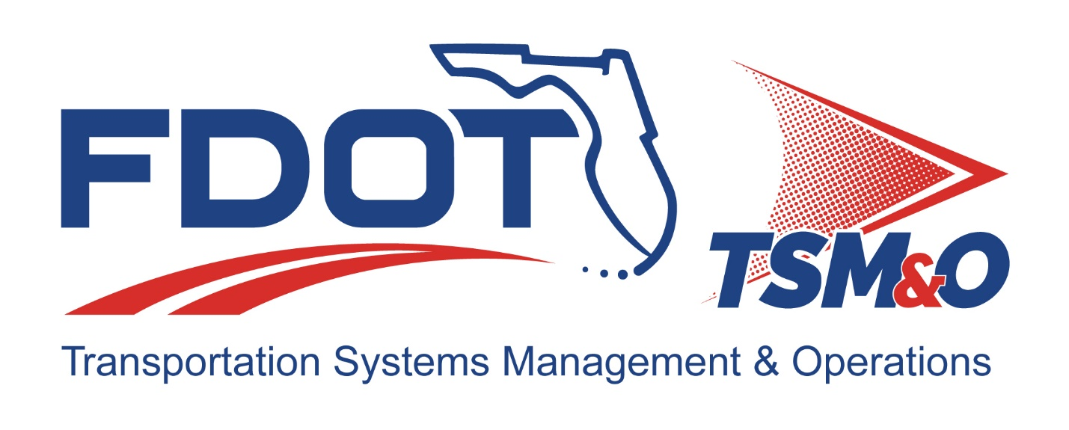

Form FM-SE-12

Risk Management Plan
TEMPLATE

TEMPLATE Version: 2.0

TEMPLATE Approval Date: 12/09/2024

Procedure for Using this Template to Create a Deliverable:
- Enter your name, firm, and date in the Author Field Document control panel.
- Replace [bracketed text] and empty sections with your project information and/or document content.
Note that bracketed text in blue italics is surrounded by brackets, using the document’s font, with the instructions on the content with which to replace the instructions. When you remove or highlight the entire bracketed portion and replace with text, the text should appear in the desired text format of the document. Also, the Document Title is a property/field of the document visible from the file system and will appear differently than with blue italics and can utilize the “Update Field” functionality.
- Each section contains instructions preceded with a checkbox for that section in blue italics. Additional helpful information and description of the required content for that section will be indicated as well, next to the lightbulb icon .
- Some sections also contain boilerplate text to use as a starting point. Review and modify the boilerplate content, if it exists, and add additional content as necessary to fulfill the requirement of each section. Use the Styles H1 – H5 for section headers, Figure Caption for captions below figures, and Table Caption for captions above tables so that the Table of Contents, List of Figures, and List of Tables can be automatically updated.
- Define acronyms at the first usage in parenthesis after the expanded term and add to the “List of Acronyms” section.
- Delete the template title page, these instructions pages, all blue instructions, and the detailed instruction notes and examples that are identified with the lightbulb throughout the document.
- Update the file name and file location in the document control panel by right-clicking the field, then select “Update Field.”
- Update the Headers and Footers to have the appropriate document title and version.
- Delete the List of Tables or List of Figures if they do not contain any items.
- Update the Table of Contents, List of Tables, and List of Figures by right-clicking and selecting “Update Field,” and then select “Update entire table.”
- Have the document modified and reviewed as appropriate, and have each reviewer and modifier enter their name, organization, and date in the document control panel.
- Submit the document for approval and go through the review/revision needed to obtain approval to finalize the document.
- Repeat the review cycle and resubmit for approval as needed to obtain approval to finalize the document.
- Enter the approver’s name, organization, and date in the “Approved By” section of the document control panel.
- Enter the approval date on the title page and in the footer throughout the document and update the revision history at the end of the document.
- Remove the DRAFT watermark on the title page and the content pages by entering the Edit Header and Footer mode of the document and deleting the DRAFT image.
- Print the document to PDF and review it outside of the Microsoft Word application.

- Submit the Word and PDF versions of the document as the final documents.

Template Revision History

Version | Date | Name | Description
1.0 | Unknown | Unknown | Original template
1.1 | 6/14/2018 | Unknown | Updated FDOT logos on form
2.0 | 12/04/2024 | Amber Greene  Stephen Bahler | Updated guidance format to match ConOps

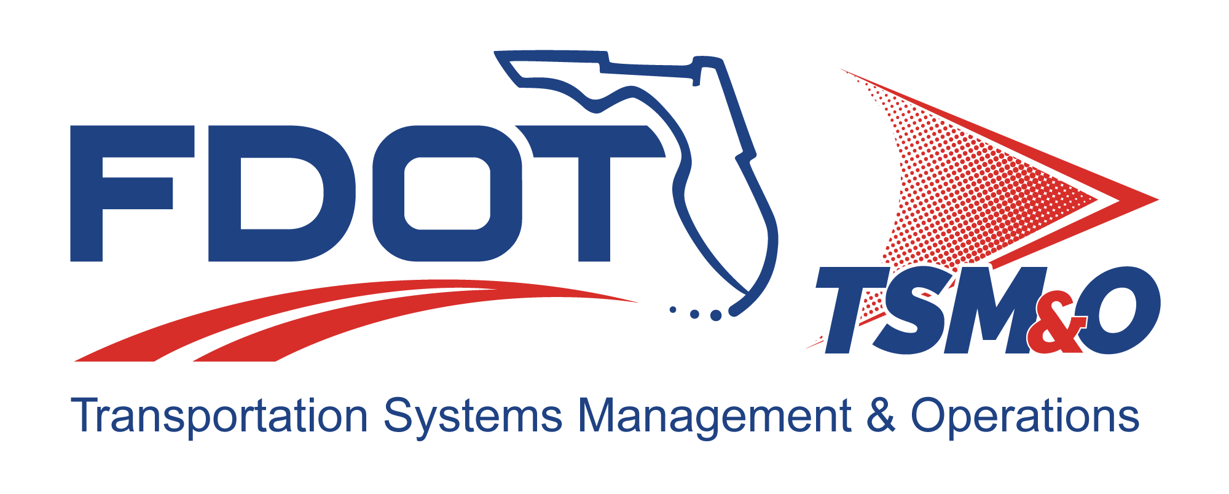

Risk Management Plan for: insert Project Name

Version: insert version number

Approval date: insert approval date

DOCUMENT CONTROL PANEL
File Name: | [insert project file name]
File Location: | [insert project file URL]
Version Number:
Name |  | Date
Created By: | [insert author name, organization] | [insert creation date]
Reviewed By: | [insert reviewer name, organization] | [insert review date]
Modified By: | [insert modifier name, organization] | [insert modified date]
Approved By: | [insert approver name, organization] | [insert approval date]
Table of Contents

1 Scope 1
1.1 Purpose 1
2 Applicable Documents 1
3 Definitions 2
4 Project Summary 3
4.1 Project Scope 3
4.2 System Description 3
5 Risk Management Strategy 3
6 Risk Management Process 3
6.1 Risk Identification 4
6.2 Risk Assessment 6
6.3 Risk Handling 7
6.4 Risk Monitoring 8
7 Risk Management Roles and Responsibilities 9
7.1 Project Manager 9
7.2 Risk Manager 10
7.3 Project Engineer 10
7.4 Risk Individual Contributor 10
7.5 Customer and Stakeholder Participation 11
7.6 Supplier Participation 11
8 User Definitions 11

List of Tables

Table 1 - [Project] Risk Summary Table 5
Table 2 - [Project] Risk Assessment 6
Table 3 - [Project] Risk Handling Strategy 8
Table 4 - [Project] Risk Monitoring Schedule 9
Table 5 - [Project} Risk Monitoring Matrix 9

List of Figures

Figure 1 – [Project] Risk Management Process 4

List of Acronyms and Abbreviations
- Update, as needed
ITS Intelligent Transportation Systems
RMP Risk Management Plan
ROM Rough Order of Magnitude

Scope

Purpose
- Update this paragraph as appropriate.
This Risk Management Plan (RMP) establishes the process for implementing proactive risk management as part of the overall management of the [Insert Project Name] intelligent transportation systems (ITS) project. The RMP is a continuous, forward-looking process that addresses issues that could endanger the achievement of critical objectives and includes early and aggressive risk identification through the collaboration and involvement of relevant stakeholders. This RMP is tailored based on a preliminary assessment of risks that have potential to critically impact project objectives. While technical issues are a primary concern both early on and throughout all project phases, risk management considers both internal and external sources for cost, schedule, and technical risk. Early and aggressive detection of risk is an ITS project objective because it is typically easier, less costly, and less disruptive to make changes and correct work efforts during the earlier, rather than later, phases of the project.

This document describes the process to:

- Tailor this list as appropriate for this project and as addressed in subsequent sections.
- Identify risk events and risk owners
- Evaluate risks with respect to likelihood and consequences
- Assess the options for the risks and develop mitigation plans
- Track risk mitigation efforts
- Conduct periodic reassessments of project risks

The RMP will be updated as necessary as the identified risks are tracked and until they are retired.

Applicable Documents
- Update this paragraph as appropriate.
This RMP has been coordinated with and draws information from the following ITS documents prepared for the [Insert Project Name] ITS project:

- Update this list of documents, add reference information, and change to a standard bullet list, as appropriate for this project. Typically, a Project Systems Engineering Management Plan addresses risk management at a high level.
- Concept of Operations
- Project Management Plan
- Project Systems Engineering Management Plan
- Software Development Plan
- Hardware Development Plan
- Configuration and Data Management Plan
- Quality Assurance Plan
- Statement of Work

Definitions
- This section defines any terms used in the RMP that may need clarification. Start with the following and tailor as necessary:
- Risk is a measure of the inability to achieve overall project objectives within defined cost, schedule, and technical constraints, and has two components: (1) the probability (or likelihood) of failing to achieve a particular outcome, and (2) the consequences of failing to achieve that outcome.
- Risk Events are those events within the project that, if unsuccessful, could result in problems in the development, production, and fielding of the system. Risk events should be defined to a level so that the risk and causes are understandable and can be accurately assessed in terms of likelihood/probability and consequences to establish the level of risk.
- Technical Risk is the uncertainty of achieving the program requirements for function, performance, and operability within the planned cost and schedule. Technical risks are associated with the ability of the system (i.e., product) design and production process to meet the level of performance necessary to satisfy the operational requirements. Failure to adequately address technical risk generally results in an inability to meet cost and schedule constraints while meeting technical requirements. Typical technical risk drivers include requirements, constraints, technology, and development approach.
- Cost Risk is the uncertainty in achieving the cost budget if none of the technical and none of the schedule risks should materialize. Cost risks are associated with the ability of the project to achieve its overall cost objectives. Two risk areas bearing on cost are (1) the risk that the cost estimates and objectives are inaccurate and/or unreasonable, and (2) the risk that project execution will not meet the cost objectives as a result of a failure to mitigate cost, schedule, and performance risks. Typical cost risk drivers include requirements, personnel availability, reuse, tools, and environment.
- Schedule Risk is the uncertainty of achieving the program schedule if none of the technical or cost risks should materialize. Schedule risks are those associated with the adequacy of the time estimated and allocated for the development, production, and fielding of the system. Two risk areas bearing on schedule risk are: (1) the risk that the schedule estimates and objectives are unrealistic and/or unreasonable, and (2) the risk that project execution will fall short of the schedule objectives as a result of failure to mitigate cost, schedule, and performance risks. Typical schedule risk drivers include requirements, need/delivery dates, technology availability, and resources.
- Project Risk is a risk that affects multiple project teams or spans the whole project structure and is subject to scrutiny at the highest levels of project management. Project risk is associated with the overall status of the project. These risks are generally associated with the ability of the project to maintain political and other support. Failure to meet cost, schedule and technical objectives can produce project risk. In addition, external budget, priority, and political considerations can produce project risk.
- Risk Assessment is the translation of risk data into information for evaluating risk and determining the likelihood and consequence. A risk assessment (or rating) is the value or level that is given to a risk event based on the analysis of the likelihood/probability and consequences of the event.
- Risk Metrics are measures used to indicate progress or achievement on risk events, for example, technical performance measures.

Project Summary

Project Scope
- This section should provide a brief description of the project’s procuring agency and scope of the project to which this RMP applies. To keep this section as brief as possible, references to the Concept of Operations for additional project owner, stakeholder, scope information are recommended.

System Description
- This section should briefly describe the system being proposed, developed, managed, analyzed, modified, integrated, supported, and/or tested. To keep this section as brief as possible, references to the Concept of Operations, Project Systems Engineering Management Plan, and other project documents for additional system description information are recommended.

Risk Management Strategy
- Start with the following RMP strategy and tailor as necessary:
The PMP strategy is to identify and handle project risks, both technical and nontechnical, before they become problems and cause serious cost, schedule, or performance impacts. The project will continuously and proactively assess critical areas identified to determine specific risks, analyze their potential impacts, determine mitigation actions, and monitor the risks.

The project will adhere to the following principles in the approach to risk management [Adapt or adjust the following bullet list based on project needs]:

- Keep it simple. Do not bother with complex mathematical equations. Use high, medium, and low. Rank the risk and develop mitigation actions accordingly.
- Everyone must participate. Successful risk management is not a one-person job. Everyone must identify and rank the risks for their area as well as identify mitigation options.
- Monitor risks frequently. Events that can alter risks occur rapidly and, thus, must be looked at frequently. Do not spend a lot of time reporting the risks but spend enough. Remember, what gets measured gets done.
- Communicate the truth. Have faith in your management and customers. Remember, they hate surprises more than bad news, and often appreciate being asked to help. They can fix requirements that violate the laws of physics or suggest innovative solutions using their assets. Honesty and early reporting are the best policy.

Risk Management Process
- Start with the following RMP process and tailor as necessary:
The risk management process for [Insert Project Name] is comprised of four phases: identification, assessment, handling, and monitoring. (Refer to Figure 1 [update figure number, if necessary].) The following paragraphs describe the process used by the project to identify and manage its risks.
Figure 1 – [Project] Risk Management Process

- The following sections describe the suggested risk management process. Projects may tailor this process and description in the following sections to best meet the needs of the project and/or satisfy the customer.
The risk management process includes the following elements:

- Risk Identification – Risk identification is the process of examining the project areas and each critical technical process to identify and document the associated risk or risks.
- Risk Assessment – Risk assessment is the process of analyzing known risks and prioritizing them based on their threat in the attainment of project goals.
- Risk Handling – Identify risk-handling options (i.e., mitigation, transfer, avoidance, assumption) and action plans, including contingency actions with implementation criteria and decision dates. Assign an owner to each risk and action plan. Ensure that risk handling plans document the criteria (i.e., observable, test, data, documentation) that justify the planned, sequential reduction of quantitative risk levels over time.
- Risk Monitoring – Track progress against action plans and established metrics to ensure timely completion of actions. Include action plans in the project integrated master schedule. Include risk name, description, identification date, owner, action plans, milestones, status, and contingency actions in the risk management database. Risk owners must provide status at least monthly.

Risk Identification
Table 1 [use table 1 or other format, as appropriate] summarizes risks identified for project [insert Project Name]. [Adapt Table 1 to add risk assessments, actions, and status in following sections.]
Table 1 - [Project] Risk Summary Table
Risk ID # | Risk Short Description | Risk Detail, Subsystem(s) Involved, and References

- Adapt the risk identification process as appropriate for the project.
- Examine all project elements in detail. Identify, describe, and document cost, schedule, technical, financial, and other risks to project success. Begin the identification process during the concept of operations and project systems engineering management plan phases and continue throughout the project life cycle. The project utilizes several methods for identifying risks [adapt the list, as appropriate]:
- Examination of the work breakdown structure to uncover risk areas
- Conductance of a risk assessment
- Interviews with subject-matter experts (i.e., engineering, manufacturing, construction, integration, operations, and maintenance)
- Reviewing risk management efforts from similar products
- Examination of lessons-learned documents or databases
- Examination of design specifications and agreement requirements

- Cost, schedule, and performance risk identification takes place during the concept phase and continues throughout the project’s life cycle. Cost risks may include those associated with funding levels, funding estimates, and distributed budgets. Schedule risks may include risks associated with planned activities, key events, and milestones. Performance risks may include risks associated with the following [adapt the list, as appropriate]:
- Requirements
- Analysis and design
- Application of new technology/processes
- Physical size, shape, weight
- Manufacturing and fabrication
- Functional performance and operation
- Verification
- Validation
- Performance maintenance attributes
- Resources (i.e., people, funds, schedules, tools, etc.)

- Individual team members involved in the detailed day-to-day technical, cost, and scheduling aspects of the program are the most aware of the potential problems (i.e., risks) that need to be managed. Program management must instill in the staff the discipline for and the importance of identifying these potential risk sources. Part of the risk assessment process will be to survey the team members for potential risk events and circumstances. The process accumulates and documents information on events or circumstances that will be evaluated to determine any potential adverse impact on the program from a technical, cost, or schedule viewpoint. The following indicators should be used:
- Lack of stability, clarity or understanding of requirements
- Failure to use best practices
- New processes
- Any process lacking rigor
- Insufficient resources
- Test failure
- Qualified supplier availability
- Negative trends or forecasts

Risk Assessment
The identified risks along with probability of occurrence and potential impact for [Insert Project Name] are documented in Table 2.

Table 2 - [Project] Risk Assessment
Risk ID # | Risk Short Description | Risk Probability | Impact Severity | Overall Risk Assessment
 |  | High | High | High
 |  | High | Medium | High
 |  | Medium | High | High
 |  | High | Low | Medium
 |  | Low | High | Medium
 |  | Medium | Medium | Medium
 |  | Medium | Low | Low
 |  | Low | Medium | Low
 |  | Low | Low | Low

- Adapt the risk assessment process as appropriate for the project.
- Estimate project exposure and establish risk-handling priorities. Qualitative assessments may be used as an initial filter, but all medium and high risks must be assessed quantitatively. Express quantitative assessments (e.g., rough order of magnitude [ROM], range of impact, factored impact, etc.) in terms of dollars, time, and performance impact, as applicable.
- During the assessment phase, the project analyzes each risk to isolate its cause and to determine its effects. The project rates the risk in terms of its probability of occurrence and its severity of impact to cost (i.e., dollars), schedule (i.e., time), and technical performance, as applicable.
- The probability of a risk issue is the chance that the risk will materialize as a “real project problem.” This probability can be expressed in quantitative (e.g., ROM, range of impact, factored impact, etc.) or qualitative terms (i.e., high, medium, or low). The risk impact is a measure of how the project is affected if the risk issue materializes. Qualitative assessments may be used as an initial filter, but all high and medium risks must be assessed quantitatively.
The criteria for the qualitative assessments shown in Table 2 follow [adapt the criteria, as appropriate]:

A high occurrence of the undesirable event will result in:

- Inability of the system to meet primary functional requirements
- Unacceptable system performance to the customer
- Late system delivery
- A project cost overrun that is not containable within management reserve

A medium occurrence of the undesirable event will result in:

- Some system requirements not being met
- A negative impact to a particular feature important to the customer
- Major intermediate milestones not being met
- A cost overrun that is containable within management reserves

A low occurrence of the undesirable event will result in:

- Some system requirements not being met
- Minor degradation of system performance
- Intermediate milestones not being met, therefore, putting a major milestone in jeopardy
- An overrun at cost account level that is offset by underruns

Overall risk assessment is the product of combining the probability of occurrence with the severity of impact as follows [use the matrix in Table 2, or similar, as appropriate for the project. Colors may be used to highlight highest potential risks.]:

- Once the risks are assessed, they may be categorized into defined risk categories, providing a means of looking at risks according to their source or taxonomy, and are prioritized from 1 to n, 1 being the most effective area to which resources for mitigation are applied to achieve the greatest positive impact to the project. If risks are prioritized, a priority column could be added to Table 2 in lieu of or in addition to colors for reference throughout the risk management process.

Risk Handling
- Adapt the risk handling process as appropriate for the project.
Table 3 describes the risk handling strategies for high, medium, and low risks for [Insert Project Name]. The strategies identify, evaluate, select, and implement options to set risk at acceptable levels given project constraints and objectives. The strategies include the specifics on what should be done, when it should be accomplished, who is responsible, and associated cost and schedule. [Update Table 3, as appropriate]

Table 3 - [Project] Risk Handling Strategy
Overall Risk Assessment | Handling Strategy
High | The project manager and project engineer status the risk on a daily basis until the risk is closed. The risk owner documents risk avoidance actions (i.e., actions taken to avoid or eliminate the source of the risk, and reduce the probability of occurrence to zero), risk mitigation actions (i.e., actions taken to mitigate the severity of the impacts of a risk and reduce the consequence to zero), and contingency actions (i.e., actions taken to protect the attainment of the project goals and to lower risk items).
Medium | This strategy provides the same handling as that for high risks, but on a less frequent basis (i.e., periodic risk status reviews, instead of daily).
Low | The project manager and project engineer add the risk to the “watchlist” for possible escalation.

- The most critical component of risk handling is the development of alternative courses of action, workarounds, and fallback positions, with a recommended course of action for each critical risk. Options for handling risks typically include alternatives such as the following:
- Risk avoidance by changing or lowering requirements, while still meeting user needs
- Risk control by taking active steps to minimize risks
- Risk transfer by reallocating design requirements to lower the risks
- Risk monitoring by watching and periodically reevaluating the risk for changes to the assigned risk parameters
- Risk acceptance by acknowledging the risk but not taking any action

Risk Monitoring
- Adapt the risk monitoring process as appropriate for the project.
- Risk monitoring systematically tracks and evaluates the performance of risk-handling actions against established metrics throughout the acquisition process and develops further risk-handling options, as appropriate. To effectively control and manage risks during the work effort, the project regularly monitors the risks and the status/results of risk-handling actions. This includes the establishment of a schedule for each risk-handling activity that includes the start date and anticipated completion date, a list of commitment of resources for each to allow successful execution of the risk-handling activities and the ultimate results of the actions taken.

Risk monitoring for [Insert Project Name] will occur regularly through project development and delivery as appropriate for the risk severity and priority. Specifically, risk monitoring will occur as outlined in Table 4 and continue until the risk is resolved or no longer a concern.

Table 4 - [Project] Risk Monitoring Schedule
Overall Risk Assessment | Cover Risk in Regular Meetings
Overall Risk Assessment | Program Review | Project Review | Phase Review | Ad Hoc
High | Yes | Yes | Yes | Yes
Medium | Yes | Yes | As needed | As needed
Low | Yes | As needed | As needed | As needed

The project master schedule will include risk review tasks, as appropriate. Project meetings will include risk review agenda items, as appropriate. The Table 5 risk monitoring matrix will be used to document risk monitoring and status. [Table 5 is an example of a simplified risk monitoring matrix]

Table 5 - [Project} Risk Monitoring Matrix
Risk ID # | Risk Short Description | Overall Risk Assessment | Risk Monitoring Status  (e.g., on-going, current action, resolved, etc.)

Risk Management Roles and Responsibilities
- This section describes the project risk management organization, including the following areas, adapt as needed.
- Include responsibility and authority of the risk management organization and the integration of risk management functions with other project activities such as technical reviews
- Included interfaces between the project risk management organization, and the customer and major subcontractors
- Insert a high-level organization chart for the project or reference a document that contains it.
- Training requirements should be addressed in this section. Include the following roles as applicable and necessary. The following sections provide a guide.

Project Manager
The project manager has the overall responsibility for risk management on the project.

- The project manager may delegate this authority to another individual or team. If this is the case, state it here.

The project manager is responsible for the following:

- Adapt the project manager’s roles, as appropriate.
- Establishing the RMP
- Providing the resources necessary to implement the RMP
- Approving the implementation of risk mitigation plans for risk rated high and providing the necessary resources
- Reviewing the project risks and directing actions as necessary
- Communicating risk activities to the project team
- Participating in the identification of risks

Risk Manager
The risk manager is the overall coordinator of the RMP. The risk manager is responsible for the following:

- Adapt the risk manager’s roles, as appropriate.
- Maintaining the RMP
- Maintaining the risk management database and monitoring matrix
- Reviewing risk control actions for completeness, feasibility, and adequacy
- Evaluating costs associated with risk control actions
- Performing risk status accounting
- Tracking efforts to reduce medium and high risks to acceptable levels
- Providing risk management training
- Facilitating risk assessments
- Preparing risk briefings, reports, and documents as required for project reviews

Project Engineer
The project engineer is responsible for the following:

- Adapt the project engineer roles, as appropriate.
- Facilitating risk identification
- Assembling risk assessment information from systems engineering activities
- Reviewing the RMP for completeness, feasibility, and adequacy
- Ensuring a timely and complete status of all systems engineering risk issues
- Reporting systems engineering risk status as part of internal reviews

Risk Individual Contributor
The risk individual contributor is responsible for the following:

- Adapt the risk individual contributor roles, as appropriate.

- Supporting risk identification
- Developing risk assessments
- Supporting risk filtering as necessary
- Developing and recording status of own risk mitigation and contingency actions
- Evaluating the effectiveness of any control actions
- Identifying and assessing any new risks as necessary
- Reporting risk status as part of internal reviews

Customer and Stakeholder Participation
- This section should describe how the customer and stakeholders will be involved in the project risk management activities. If customer and stakeholder involvement is planned, the project leadership team works with the customer to define the details of this involvement. and this definition is documented and communicated to the project team and to the customer.

Supplier Participation
- This section should describe how the suppliers will be involved in the project risk management activities. Suppliers can be a key part of controlling risks and supplier participation should be strongly considered. If supplier involvement is planned, the project leadership team works with suppliers to define the details of this involvement, and this definition is documented and communicated to the project team and to the customer.

User Definitions
- Add user definitions if different from typical definition usage in this template.

DOCUMENT REVISION HISTORY
Version Number | Approved Date | Description of Change(s) | Created/  Modified By

