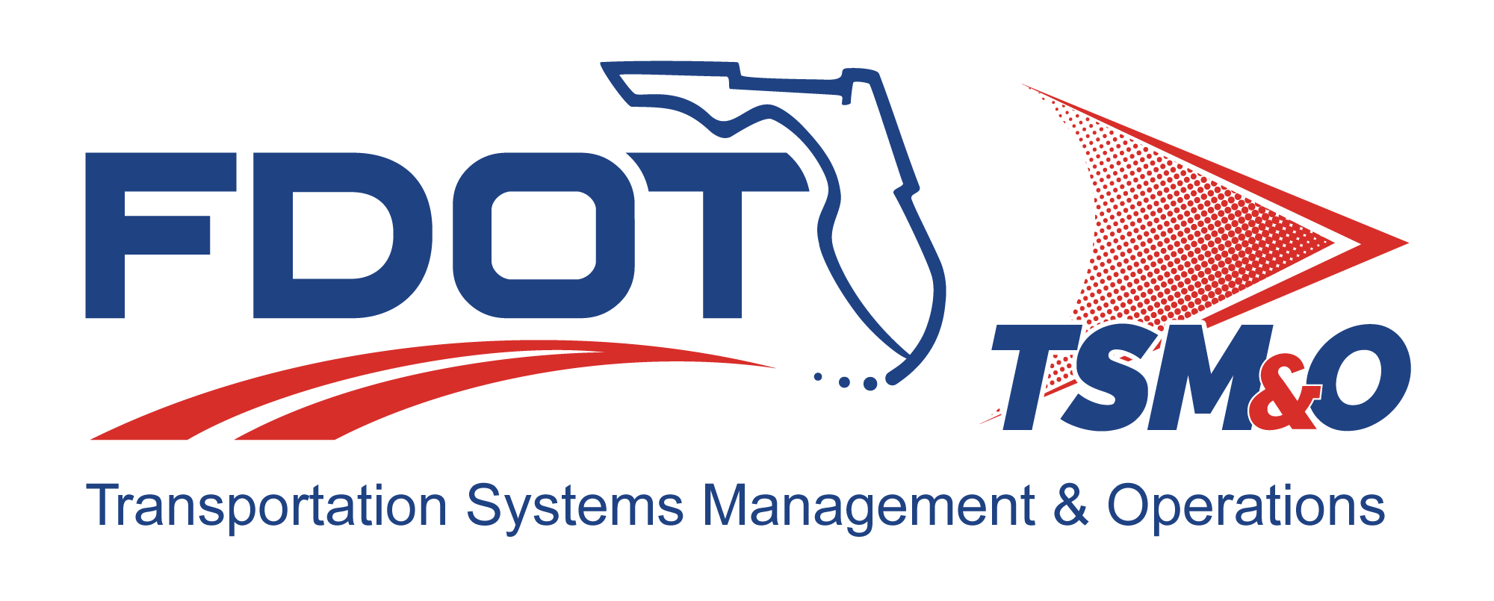

Form FM-SE-16

Subcontract Management Plan
TEMPLATE

TEMPLATE Version: 2.0

TEMPLATE Approval Date: 12/09/2024

Procedure for Using this Template to Create a Deliverable:
- Enter your name, firm, and date in the Author Field Document control panel.
- Replace [bracketed text] and empty sections with your project information and/or document content.
Note that bracketed text in blue italics is surrounded by brackets, using the document’s font, with the instructions on the content with which to replace the instructions. When you remove or highlight the entire bracketed portion and replace with text, the text should appear in the desired text format of the document. Also, the Document Title is a property/field of the document visible from the file system and will appear differently than with blue italics and can utilize the “Update Field” functionality.
- Each section contains instructions preceded with a checkbox for that section in blue italics. Additional helpful information and description of the required content for that section will be indicated as well, next to the lightbulb icon .
- Some sections also contain boilerplate text to use as a starting point. Review and modify the boilerplate content, if it exists, and add additional content as necessary to fulfill the requirement of each section. Use the Styles H1 – H5 for section headers, Figure Caption for captions below figures, and Table Caption for captions above tables so that the Table of Contents, List of Figures, and List of Tables can be automatically updated.
- Define acronyms at the first usage in parenthesis after the expanded term and add to the “List of Acronyms” section.
- Delete the template title page, these instructions pages, all blue instructions, and the detailed instruction notes and examples that are identified with the lightbulb throughout the document.
- Update the file name and file location in the document control panel by right-clicking the field, then select “Update Field.”
- Update the Headers and Footers to have the appropriate document title and version.
- Delete the List of Tables or List of Figures if they do not contain any items.
- Update the Table of Contents, List of Tables, and List of Figures by right-clicking and selecting “Update Field,” and then select “Update entire table.”
- Have the document modified and reviewed as appropriate, and have each reviewer and modifier enter their name, organization, and date in the document control panel.
- Submit the document for approval and go through the review/revision needed to obtain approval to finalize the document.
- Repeat the review cycle and resubmit for approval as needed to obtain approval to finalize the document.
- Enter the approver’s name, organization, and date in the “Approved By” section of the document control panel.
- Enter the approval date on the title page and in the footer throughout the document and update the revision history at the end of the document.
- Remove the DRAFT watermark on the title page and the content pages by entering the Edit Header and Footer mode of the document and deleting the DRAFT image.
- Print the document to PDF and review it outside of the Microsoft Word application.
- Submit the Word and PDF versions of the document as the final documents.
- Provide tables and graphics to display information, as needed:
  - Table styles may use the following example format, or others as needed
  - Placement of table captions above the table and left justified is recommended.
- Provide figures when need to convey information to augment written descriptions:
  - Placement of figure captions below and center justified is recommended.

Template Revision History

Version | Date | Name | Description
1.0 | 6/14/2018 | Unknown
2.0 | 12/06/2024 | Steve Bahler  Amber Greene | Update template to current template format and content.

Subcontract Management Plan for: insert project name

Version: insert version number

Approval date: insert approval date

DOCUMENT CONTROL PANEL
File Name: | [insert project file name]
File Location: | [insert project file URL]
Version Number: | [insert version #]
Name |  | Date
Created By: | [insert author name, organization] | [insert creation date]
Reviewed By: | [insert reviewer name, organization] | [insert review date]
Modified By: | [insert modifier name, organization] | [insert modified date]
Approved By: | [insert approver name, organization] | [insert approval date]
Table of Contents

1 Overview 1
1.1 Scope 1
1.2 Reference Documents 1
2 Organization and Responsibilities 2
3 Subcontracting Plan / Subcontractor Work Distribution 2
4 Task Work Order Management Process 2
5 Quality Assurance 2
6 Staffing 2
7 Financial 3
8 Technical 3
9 Management 3
9.1 Risk Management 3
9.2 Change Management 3
9.3 Subcontract Closeout Management 3
10 Invoice and Financial Status Reporting 3
11 Communications and Problem Resolution 3
12 User Definitions 4

List of Tables

Table 1: Title 3

List of Figures

Figure 1: Title 3

List of Acronyms and Abbreviations

FDOT Florida Department of Transportation
ITS Intelligent Transportation Systems
PMP Project Management Plan
PSEMP Project Systems Engineering Management Plan
QMP Quality Management Plan
RMP Risk Management Plan
SMP Subcontract Management Plan

- The Subcontract Management Plan (SMP) describes the process used by the Florida Department of Transportation (FDOT) to select qualified intelligent transportation systems (ITS) subcontractors and manage them efficiently Typically, Subcontractor management is addressed in the Project Systems Engineering Management (PSEMP). A SMP is recommended when required by the PSEMP for highly specialized Subcontractors or unique subcontracting scenarios. The SMP combines the concerns of requirements management, project planning, project tracking, and project oversight for basic management control, along with necessary coordination of quality assurance and configuration management and applies this control to the subcontractor as appropriate.

Overview
The Subcontract Management Plan (SMP) describes the process used by the Florida Department of Transportation (FDOT) to select qualified intelligent transportation systems (ITS) subcontractors and manage them efficiently for the [Insert Project Name].

Scope
The SMP sets forth the processes for managing and integrating project activities and provides methods and guidance for the selection and management of subcontractors using proven processes and methods that assure successful program execution.

The scope of the SMP begins at the preproposal stage and continues through subcontract execution, performance management, and closeout. The SMP will be updated [annually or as required] to reflect changes in subcontractor management functions and/or processes. It provides guidance for subcontract management activities, including:

- Organization, roles, and responsibilities
- Methods and processes for subcontractor management
- Management oversight for all subcontractors to minimize program impacts due to cost, schedule, or technical performance
- Distribution of work
- Subcontract task work order allocation
- Quality assurance of deliverables/products
- Status reporting and invoice procedures
- Ongoing communications

Reference Documents
- This section lists the number, title, revision, and date of all documents referenced in this plan.
- Include file locations, if possible.

- FDOT documents
- Project plans
- Operational procedures
- Engineering instructions

Organization and Responsibilities
- This section describes the organization and responsibilities associated with the subcontract management process, including:
- Project management
- Business management
- Contracts and subcontract administration
- Engineering
- Environmental; health and safety; and security
- Quality assurance

Subcontracting Plan / Subcontractor Work Distribution
- This section describes the allocation/distribution of work among the project’s subcontractor team.
- Reference to the PSEMP, and/or the Project Management Plan (PMP), as applicable.

Task Work Order Management Process
- This section provides the management process for task work order responsibilities, including:
- Subcontractor task work order management
- Task work order staffing process

Quality Assurance
- This section describes the key areas that may be utilized for measuring teammate performance, including the staffing, financial, technical, and management areas.
- Reference the Quality Management Plan (QMP) and/or the PSEMP, if applicable.

Staffing
- This section describes staffing performance and how it is measured.

- The performance may be measured by performing an analysis of the open/filled ratio, and the timeframe required to fill open or vacant positions.

Financial
- This section describes the key financial elements that are monitored for ongoing analysis.

Technical
- This section describes the key factors monitored for subcontractor technical performance, including:

- Delivery of excellent performance
- Customer support

Management

Risk Management
- This section describes the process where performance problems are reported to the project management. It further establishes the process in which the project manager responds to problems and develops an action plan to ensure problem resolution.
- Reference the PSEMP and/or the Risk Management Plan (RMP), as applicable.

Change Management
- This section describes the control and exercise of all subcontract change or modification actions.

Subcontract Closeout Management
- This section describes the procedure for how closeout of the subcontract will be managed.
- Reference the PSEMP, as applicable.

Invoice and Financial Status Reporting
- This section describes the process for receipt of services and how invoices are processed for payment.

Communications and Problem Resolution
- This section establishes the key methods for subcontractor communications and how all issues/concerns are resolved when they arise.

Table 1: Title

Figure 1: Title

User Definitions

DOCUMENT REVISION HISTORY
Version Number | Approved Date | Description of Change(s) | Created/  Modified By

