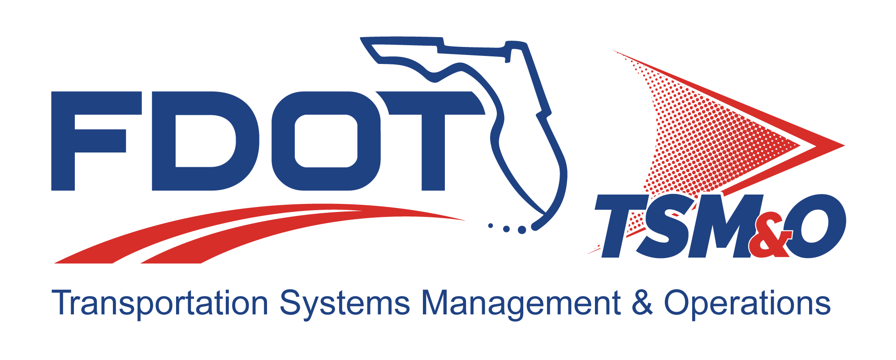

Form FM-SE-19

Test Procedures
TEMPLATE

TEMPLATE Version: 2.0

TEMPLATE Approval Date: TBD

Procedure for Using this Template to Create a Deliverable:
- Enter your name, firm, and date in the Author Field Document control panel.
- Replace [bracketed text] and empty sections with your project information and/or document content.
Note that bracketed text in blue italics is surrounded by brackets, using the document’s font, with the instructions on the content with which to replace the instructions. When you remove or highlight the entire bracketed portion and replace with text, the text should appear in the desired text format of the document. Also, the Document Title is a property/field of the document visible from the file system and will appear differently than with blue italics and can utilize the “Update Field” functionality.
- Each section contains instructions preceded with a checkbox for that section in blue italics. Additional helpful information and description of the required content for that section will be indicated as well, next to the lightbulb icon .
- Some sections also contain boilerplate text to use as a starting point. Review and modify the boilerplate content, if it exists, and add additional content as necessary to fulfill the requirement of each section. Use the Styles H1 – H5 for section headers, Figure Caption for captions below figures, and Table Caption for captions above tables so that the Table of Contents, List of Figures, and List of Tables can be automatically updated.
- Define acronyms at the first usage in parenthesis after the expanded term and add to the “List of Acronyms” section.
- Delete the template title page, these instructions pages, all blue instructions, and the detailed instruction notes and examples that are identified with the lightbulb throughout the document.
- Update the file name and file location in the document control panel by right-clicking the field, then select “Update Field.”
- Update the Headers and Footers to have the appropriate document title and version.
- Delete the List of Tables or List of Figures if they do not contain any items.
- Update the Table of Contents, List of Tables, and List of Figures by right-clicking and selecting “Update Field,” and then select “Update entire table.”
- Have the document modified and reviewed as appropriate, and have each reviewer and modifier enter their name, organization, and date in the document control panel.
- Submit the document for approval and go through the review/revision needed to obtain approval to finalize the document.
- Repeat the review cycle and resubmit for approval as needed to obtain approval to finalize the document.
- Enter the approver’s name, organization, and date in the “Approved By” section of the document control panel.
- Enter the approval date on the title page and in the footer throughout the document and update the revision history at the end of the document.
- Remove the DRAFT watermark on the title page and the content pages by entering the Edit Header and Footer mode of the document and deleting the DRAFT image.
- Print the document to PDF and review it outside of the Microsoft Word application.
- Submit the Word and PDF versions of the document as the final documents.
- Provide tables and graphics to display information, as needed:
  - Table styles may use the following example format, or others as needed
  - Placement of table captions above the table and left justified is recommended.
- Provide figures when need to convey information to augment written descriptions:
  - Placement of figure captions below and center justified is recommended.

Template Revision History

Version | Date | Name | Description
1.0 | 6/14/2018 | Unknown
2.0 | 12/10/2024 | Amber Greene | Update template to current template format and content.
2.0 | 03/16/2025 | Steve Bahler | Update template content and for conformance with FM-SE-18 System Test Plan.

Test Procedures for: insert project name

Version: insert version number

Approval date: insert approval date

DOCUMENT CONTROL PANEL
File Name: | [insert project file name]
File Location: | [insert project file URL]
Version Number: | [insert version #]
Name |  | Date
Created By: | [insert author name, organization] | [insert creation date]
Reviewed By: | [insert reviewer name, organization] | [insert review date]
Modified By: | [insert modifier name, organization] | [insert modified date]
Approved By: | [insert approver name, organization] | [insert approval date]
Table of Contents

1 Introduction 1
1.1 Purpose 1
1.2 System Overview 1
1.3 Definitions 1
2 Reference Documents 2
3 Test Procedures 3
3.1 Procedure for TC [insert TC ID from System Test Plan] 3
3.1.1 Test Preparation 3
3.1.1.1 Test Setup 3
3.1.1.2 Test Equipment 3
3.1.1.3 Test Support 3
3.1.1.4 Test Reporting Requirements 4
3.1.2 Test Procedures 4
3.2 Procedure for TC [Insert TC ID for 2nd TC] 4
3.3 Procedure for TC [Insert TC ID for 3rd TC] 4
3.4 Procedure for TC 4 through N [Insert applicable TC IDs] 4

List of Tables

Table 1: Test Report Special Definitions 1
Table 2: [Project Name] System Test Plan References 3
Table 3: TC [Insert ID #] Test Procedure 4
Table 4: Sample Table 5

List of Figures

Figure 1: Title 5

List of Acronyms and Abbreviations

CF Critical Failure
IC Integration Case
MF Minor Failure
P Pass
PSEMP Project Systems Engineering Management Plan
RTVM Requirement Traceability Verification Matrix
SF Serious Failure
TC Test Case

- Test procedures are required if a System Test Plan has been developed to describe specific Test Cases (TCs) that are intended to verify specific Integration Cases (ICs) for an Intelligent Transportation System Project.
- Each TC requires a corresponding test procedure.
- A unique test procedure may apply to more than one TC.

Introduction
- Introduce the reader to the subject of the document and include a brief project description.
- Update the narrative, as appropriate
- The System Test Plan (Template FM-SE-18) and the Test Procedure may be combined into one document as directed by FDOT Project Manager.

Purpose
This document describes test procedures associated with the System Test Plan for [Insert Project Name]. A test procedure is prepared for each Test Case (TC) in the System Test Plan. Each test procedure incudes testing step identification, the procedure for each step, the expected result, and the pass/fail criteria. The results of the pass/fail criteria are transferred to the Requirements Traceability Verification Matrix (RTMV).

System Overview
- Summarize the component to component, subsystem, and system integration cases (ICs) by referencing the System Test Plan, the Project Systems Engineering Management Plan (PSEMP), the RTVM, or other documents, as appropriate.
- It is not necessary to provide system diagrams or block diagrams in this document.

The component to component, subsystems, and system integration cases (ICs) are described in the System Test Plan for [Insert Project Name].

Definitions
Table 1: Test Report Special Definitions
Term | Term Definition
Pass/Fail | Pass (P) is used when no exceptions to the expected results are identified.  There are three types of failure categories: 1) Fail Repair, which requires retesting; 2) Fail Deviation Required; and 3) Fail Waiver Required. This explanation is followed by a summary table listing the number of requirements in each category.
Minor Failure (MF) | Minor failures do not materially impact the operation of the system, and can be fixed at a later date or ignored. An example might be a user interface display that has a misspelling in it or the wrong color used for an icon on the display. These failures can be listed as Failure Deviation Required or Failure Waiver Required.
Serious Failure (SF) | Serious failures are those that need to be fixed, but an interim solution exists that can be used to operate the system. Usually, an interim solution is a manual operation, such as entering data into a database directly or selecting certain system output configurations instead of letting the software do it. These failures can be listed as Failure Deviation Required. The work-around solution is described, and a recommendation is made to implement the work-around and have the contractor fix the failure before the final release of the system. If it is determined that it is not cost effective to fix the failure and retest, and if the work-around solution is adequate for the long term, the failure may be listed as Failure Waiver Required, meaning the FDOT will grant the contractor a waiver for that requirement. Usually, a waiver is granted in return for some form of consideration from the contractor, such as a reduced fee or other additional functionality that wasn’t specified but later desired.
Critical Failure (CF) | Critical failures must be fixed before further testing of the system can continue. The system cannot be deployed or operated with a critical failure. These are sometimes referred to as “show stoppers.” This section explains what a critical failure means and is followed by a three-column table identifying the requirements, the text of the requirement, the reason it failed, and why it is critical that it be fixed before continued testing or operation takes place.

Reference Documents
The following documents, of the exact issue shown, form a part of this document to the extent specified herein. In the event of a conflict between the documents referenced herein and the contents of this document, this document shall be considered the superseding requirement.

- List all reference material that is used in the integration and testing plan.
- Do not list any documents not specifically referenced in the body of the document.
- Include references to project-specific Florida Department of Transportation standards and procedures used in the development of the requirements.
- If this document produces a change to a referenced document, particularly the RTVM, the referenced document should be updated to reflect the change.

Table 2: [Project Name] System Test Plan References
Reference Document Name | Version/Date | File Location | Owner Organization or Publisher

Test Procedures
This section lists the step-by-step procedures to be followed for each TC described in the System Test Plan.

- In this template, the procedures are described for each TC described in the System Test Plan.

Procedure for TC [Insert TC ID from System Test Plan]
- Prepare a procedure for each TC in the System Test Plan.

Test Preparation

Test Setup
- Describe the test set up required for this series of tests.
- When applicable, a diagram of test set up requirements is recommended.

Test Equipment
- List the equipment needed for the test. This is just a list, not a detailed explanation of the pieces.
- List cables and connectors required.
- Identify additional equipment that is needed to support the testing.

Test Support
- Describe person or personnel who will perform the procedure steps and roles.
- Provide system owner role, if not the person performing the test procedure.
- If some equipment or services are required external to the project, describe who will provide them and how they will be injected into the testing.
- Describe any simulator or test data files that will be needed to conduct the testing or to support technical analysis.
- Describe applicable system security or access requirements.

Test Reporting Requirements
- Briefly describe the requirements for reporting test results and what process will be followed to dispose of any test anomalies (e.g., partial, or complete failure to meet a requirement).
- Test reporting could be as brief as documenting pass/fail in the RTVM or as detailed as generating a stand-alone report using FDOT Template FM-SE-20.
- A stand-alone report may be applicable if the test procedure is for a TC that includes analysis or testing test methods (See FM-SE-18).

Test Procedures
- Keep the test procedures to a manageable size where there are a maximum of 25 to 30 steps. State the test objective for each test procedure and identify the requirements being tested.
- Use a table format to document the test procedure.

Table 3: TC [Insert ID #] Test Procedure
Step | Procedure | Expected Result | Pass/Fail | Comments
1 | [Describe the step to be taken.] | [Describe the expected result.] | [P, MF, SF, or CF] | [If step failed, describe the failure and actions taken as a result.]
2
3
4
N
Overall Test Results (P/F)

- Each TC Test Procedure can be printed and filled out by testing personnel and inserted into the Test Report (FM-SE-20) for documentation of test results.
- Insert rows into the table until all steps are described. “N’ represents the last step.

Procedure for TC [Insert TC ID for 2nd TC]
- Repeat outline from Section 3.1 and provide content appropriate for the 2nd TC.

Procedure for TC [Insert TC ID for 3rd TC]
- Repeat outline from Section 3.1 and provide content appropriate for the 3rd TC.

Procedure for TC 4 through N [Insert applicable TC IDs]
- Repeat outline from Section 3.1 and provide content appropriate for the remaining TC.
- Continue listing until all procedures have been included.

Table 4: Sample Table

Figure 1: Title

DOCUMENT REVISION HISTORY
Version Number | Approved Date | Description of Change(s) | Created/  Modified By

