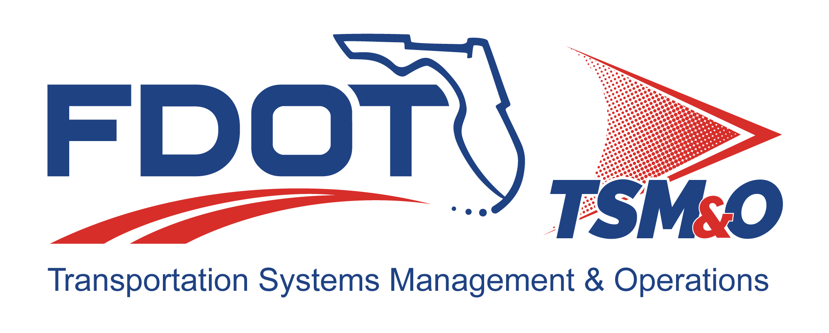

Form FM-SE-20

Test Report
TEMPLATE

TEMPLATE Version: 2.0

TEMPLATE Approval Date: TBD

Procedure for Using this Template to Create a Deliverable:
- Enter your name, firm, and date in the Author Field Document control panel.
- Replace [bracketed text] and empty sections with your project information and/or document content.
Note that bracketed text in blue italics is surrounded by brackets, using the document’s font, with the instructions on the content with which to replace the instructions. When you remove or highlight the entire bracketed portion and replace with text, the text should appear in the desired text format of the document. Also, the Document Title is a property/field of the document visible from the file system and will appear differently than with blue italics and can utilize the “Update Field” functionality.
- Each section contains instructions preceded with a checkbox for that section in blue italics. Additional helpful information and description of the required content for that section will be indicated as well, next to the lightbulb icon .
- Some sections also contain boilerplate text to use as a starting point. Review and modify the boilerplate content, if it exists, and add additional content as necessary to fulfill the requirement of each section. Use the Styles H1 – H5 for section headers, Figure Caption for captions below figures, and Table Caption for captions above tables so that the Table of Contents, List of Figures, and List of Tables can be automatically updated.
- Define acronyms at the first usage in parenthesis after the expanded term and add to the “List of Acronyms” section.
- Delete the template title page, these instructions pages, all blue instructions, and the detailed instruction notes and examples that are identified with the lightbulb throughout the document.
- Update the file name and file location in the document control panel by right-clicking the field, then select “Update Field.”
- Update the Headers and Footers to have the appropriate document title and version.
- Delete the List of Tables or List of Figures if they do not contain any items.
- Update the Table of Contents, List of Tables, and List of Figures by right-clicking and selecting “Update Field,” and then select “Update entire table.”
- Have the document modified and reviewed as appropriate, and have each reviewer and modifier enter their name, organization, and date in the document control panel.
- Submit the document for approval and go through the review/revision needed to obtain approval to finalize the document.
- Repeat the review cycle and resubmit for approval as needed to obtain approval to finalize the document.
- Enter the approver’s name, organization, and date in the “Approved By” section of the document control panel.
- Enter the approval date on the title page and in the footer throughout the document and update the revision history at the end of the document.
- Remove the DRAFT watermark on the title page and the content pages by entering the Edit Header and Footer mode of the document and deleting the DRAFT image.
- Print the document to PDF and review it outside of the Microsoft Word application.
- Submit the Word and PDF versions of the document as the final documents.
- Provide tables and graphics to display information, as needed:
  - Table styles may use the following example format, or others as needed
  - Placement of table captions above the table and left justified is recommended.
- Provide figures when need to convey information to augment written descriptions:
  - Placement of figure captions below and center justified is recommended.

Template Revision History

Version | Date | Name | Description
1.0 | 6/14/2018 | Unknown
2.0 | 1/3/2025 | Amber Greene | Update template to current template format and content.
2.0 | 04/10/2025 | Steve Bahler | Update content and harmony with templates FM-SE-18 and FM-SE-19.

Test Report for: insert project name

[Also, insert Test Case ID and Name, if applicable]

Version: insert version number

Approval date: insert approval date

DOCUMENT CONTROL PANEL
File Name: | [insert project file name]
File Location: | [insert project file URL]
Version Number: | [insert version #]
Name |  | Date
Created By: | [insert author name, organization] | [insert creation date]
Reviewed By: | [insert reviewer name, organization] | [insert review date]
Modified By: | [insert modifier name, organization] | [insert modified date]
Approved By: | [insert approver name, organization] | [insert approval date]
Table of Contents

1 Background 1
1.1 Purpose 1
1.2 Referenced Documents 1
1.3 Definitions 1
2 Test Results Summary 2
3 Detailed Test Results 3
3.1 TC 1 Results 3
3.1.1 TC Adherence 3
3.1.2 Test Procedure Adherence 3
3.1.3 Test Log 3
3.1.4 Test Documentation 4
3.1.5 Test Data Sheets 4
3.1.6 Analysis and Conclusions 4
3.2 TC 2 through N 4
4 Raw Test Data Files 5

List of tables

Table 1: [Project Name] Test Report Reference Documents 1
Table 2: Test Report Special Definitions 1
Table 3: Test Results Summary 2
Table 4: TC [Insert TC ID] Test Log 4
Table 5: Sample Table Title 6

List of Figures

Figure 1: Title 6

List of Acronyms and Abbreviations

CF Critical Failure
FDOT Florida Department of Transportation
IC Integration Case
ITS Intelligent Transportation Systems
MF Minor Failure
P Pass
SF Serious Failure
TC Test Case

Background
- Modify the following paragraph, as appropriate.

Purpose
This report documents test results for Intelligent Transportation System (ITS) Project [Insert Project Name] where a stand-alone test report is required in accordance with the Test Procedure (FM-SE-19) document. Other test results are documented in the Requirements Traceability Verification Matrix (RTVM).

Referenced Documents
Table 1: [Project Name] Test Report Reference Documents
Reference Document Name | Version/Date | File Location | Owner Organization or Publisher
[Include System Test Plan Reference]
[Include Test Procedure Reference]
[Include Requirements Traceability Verification Matrix Reference]
[Add other reference, as needed]

- Include other references, as appliable, but only documents referenced in the report.

Definitions
Table 2: Test Report Special Definitions
Term | Term Definition
Pass/Fail | There are three types of failure categories: 1) Fail¬ Repair, which requires retesting; 2) Fail Deviation Required; and 3) Fail Waiver Required. This explanation is followed by a summary table listing the number of requirements in each category.
Minor Failure (MF) | Minor failures do not materially impact the operation of the system, and can be fixed at a later date or ignored. An example might be a user interface display that has a misspelling in it or the wrong color used for an icon on the display. These failures can be listed as Failure-Deviation Required or Failure-Waiver Required.
Serious Failure (SF) | Serious failures are those that need to be fixed, but an interim solution exists that can be used to operate the system. Usually, an interim solution is a manual operation, such as entering data into a database directly or selecting certain system output configurations instead of letting the software do it. These failures can be listed as Failure-Deviation Required. The work-around solution is described, and a recommendation is made to implement the work-around and have the contractor fix the failure before the final release of the system. If it is determined that it is not cost effective to fix the failure and retest, and if the work-around solution is adequate for the long term, the failure may be listed as Failure-Waiver Required, meaning the FDOT will grant the contractor a waiver for that requirement. Usually, a waiver is granted in return for some form of consideration from the contractor, such as a reduced fee or other additional functionality that wasn’t specified but later desired.
Critical Failure (CF) | Critical failures must be fixed before further testing of the system can continue. The system cannot be deployed or operated with a critical failure. These are sometimes referred to as “show stoppers.” This section explains what a critical failure means and is followed by a three-column table identifying the requirements, the text of the requirement, the reason it failed, and why it is critical that it be fixed before continued testing or operation takes place.

Test Results Summary
This section provides the executive summary of the test, and should provide a quick summary of the test results and the recommended actions to be taken. Refer to the Test Requirements document for details on TC descriptions. Refer to the RTVM for test results for TC that do not require a stand-alone test report.

Table 3: Test Results Summary
TC ID | Test Results |  |  |  | Summary of Recommended Actions
TC ID | Pass | Minor Failure | Serious Failure | Critical Failure | Summary of Recommended Actions
TC #01
TC #02
TC #03
TC #N

- Include TCs that require a stand-alone test report.
- Add rows for TCs, as needed.
- If symbols are used to denote test results other than an “X”, define the symbols.
- The recommended action should briefly summarize how to proceed when a test results in a failure. Examples include: retest, pursue an exception, fix the system but no retest required, etc.

Detailed Test Results
- This section presents the test documentation that supports the conclusions and recommendations in Section 2 of this template. This support documents one-on-one results for each step in the Test Procedure for each TC.

TC 1 Results

TC Adherence
- Note whether the TC elements, integration, configuration, and functional requirements were followed as described in the System Test Plan, or if any changes, additions, or omissions of the System Test Plan occurred.
- Provide enough detail about changes for an independent reviewer to conclude that the change did not impact the validity of the test results.
- Provide rationale for changes, additions, or omissions.
- It is recommended that the System Test Plan and the Test Procedure be updated to reflect significant changes, additions, or omissions that occurred during testing.

Test Procedure Adherence
- Note whether the step-by-step test procedure was followed, or if any changes, additions, or omissions of the test procedure occurred.
- Provide enough detail about changes for an independent reviewer to conclude that the change did not impact the validity of the test results.
- Provide rationale for changes, additions, or omissions.
- It is recommended that the Test Procedure be updated to reflect significant changes, additions, or omissions that occurred during testing.

Test Log
- Copy the step-by-step Test Procedure for the TC.
- Add a column to note test results (pass and fail level)

Table 4: TC [Insert TC ID] Test Log
Step | Procedure | Expected Result | Pass/Fail | Comments
1 | [Describe the step to be taken from Test Procedure (FM-SE-19).] | [Describe the expected result from Test Procedures FM-SE-19).] | [P, MF, SF, or CF] | [If step failed, describe the failure and actions taken as a result.]
2
3
4
N
Overall Test Results (P/F)

- Keep documenting chronological step results until the test procedure is complete.
- Use the overall test results to complete the test results summary table.

Test Documentation
- Test files and system reports that support the test conclusions and recommendations for the particular integration (or test) case are included in this section.
- If dummy test data was inserted into the system as a part of the test, the actual test data file is listed here.

Test Data Sheets
- Include a copy of the Test Procedure table with the pass/fail and comment boxes filled here. Usually, this is a marked up copy of the Test Procedure Table and it is photocopied into this document. There should be no attempt to clean up the test data sheets.

Analysis and Conclusions
- Provide a detailed analysis of each failure, explaining why the system failed to meet the requirement (if known) or what the failure may be related to. It is acceptable to conclude that the requirement as stated cannot be met by the system without a major redesign of the system or that the requirement was not correctly stated. Specific recommendations and the rationale for the recommendations complete this section.

TC 2 through N
- This section is in the same format as TC 1 above. Continue until all TCs described in the test procedures have been addressed.

Raw Test Data Files
- This section contains a list of the raw data extracted from the system that was used to analyze the system’s performance.
- This may be a separate document if large amounts of data were produced.

Table 5: Sample Table Title

Figure 1: Title

DOCUMENT REVISION HISTORY
Version Number | Approved Date | Description of Change(s) | Created/  Modified By

